  Parent Society | 2014 Pre-Conference Newsletter    Southern Region  American Society for Horticultural Science |   Member SAAS

In This Issue | page
Note From the President | 1
About the 2014 Annual Meeting | 2
Pre-Registration and Registration Info | 2
Hotel Registration Information | 2
Notes to Paper Presenters | 3
Oral Paper Presentation Format | 3
Poster Preparation Instructions | 3
Abstract Preparation Instructions | 3
Note to Section Chairs and Judges | 3
Fall 2013 Election Results | 4
Dues and Membership | 4
Future Meeting Dates | 4
2012-2013 Officers/Chairs/Committees | 5
Abstract Preparation Guidelines | 7
Tentative Program Schedule | 8

Message from the President
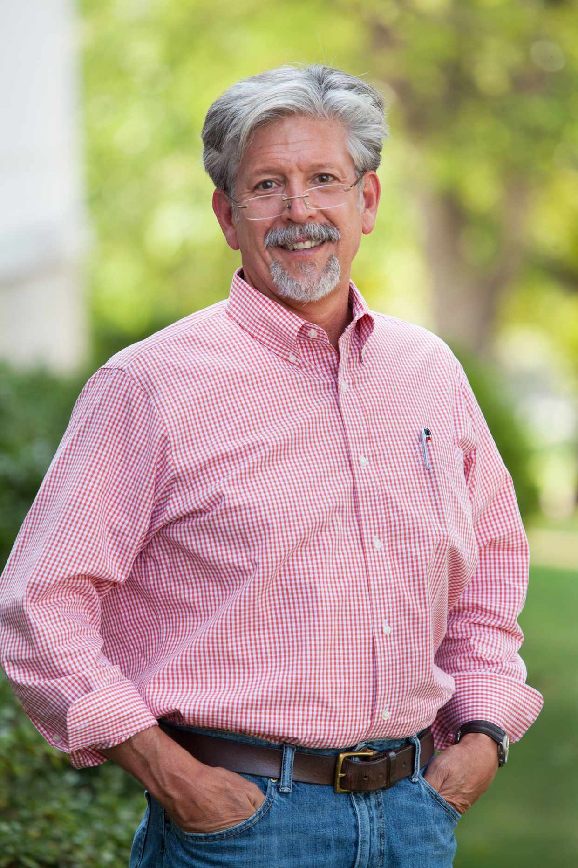 | It is the “Super Weekend”. One of the signs of the end of winter and the harbinger of spring for the southern region is Super Sunday. I know most of you are thinking about the Super Bowl. But, I am thinking about the super time we have as the Southern Region of the American Society for Horticultural Sciences at our
annual meeting in conjunction with the Southern Association of Agricultural Scientists. Just as I look forward to the lengthening and warming days of February as spring approaches, I look forward to our annual meeting. It is a time to share our knowledge, experience, research and academic activity; it is a time to renew collegial friendships and make new collaborative associations; it is a time to recognize achievements. The meeting is productive and fun, intellectually rewarding and personally satisfying.
The first time I attended the SR-ASHS meeting was when I was an undergraduate student. I believe that experience helped forge my career. At the meeting, I found out that the discipline of horticulture was much larger than the circle of professors and friends at my university; horticulture was something much bigger. Also, at that meeting I heard my first scientific presentations and was enlivened by that experience. The breadth of science that I saw at that meeting showed me that horticulture research and education was a big thing and “Horticulture was Growing!” I left the region for a decade and was in both the northeast and western regions. Those regions were not active in the ASHS and did not regularly conduct meetings. When I returned to the Southern Region, I was delighted to return to the annual SR-ASHS meetings. This year I will celebrate 25 years of attending the meetings.
I encourage you to attend. Further I strongly encourage the participation of undergraduates, graduates and post docs in our classes and laboratories. We want you there – bring your students and bring your colleagues. Participation in this meeting will demonstrate to them that Horticulture is Growing. The meetings are a great time to share our work, knowledge, discoveries, and innovations. It is a time to build our professional networks and forge collaborations. It is a time for students to engage and shine – and a great opportunity for us to recruit new students to our groups. It is a time for us to acknowledge the accomplishments and leadership of our students and colleagues with awards – and to celebrate their achievements.
For those of you who are returning to the meetings, you will notice a change. Based upon membership input, the executive committee has changed the schedule with the meetings beginning on Friday, a large group of activities on Saturday, and the meetings concluding on Sunday with the SAAS Super Bowl reception and party. It is hoped that with this schedule change, the meetings will be more convenient and attractive to the membership and that this will encourage stronger participation
Inside of this newsletter you will find the information regarding registration, hotels, and the program schedule. You can find the contact information for leadership in the SR-ASHS. Make your plans to attend, today.
We are just weeks away from a Super Sunday. I look forward to seeing you there. I am excited to once again welcome spring and see that in this season, Horticulture is Growing. It is Super!

About the 2014 Annual Meeting
95th Annual Meeting
Dallas, TX
January 31 - February 2, 2014
The Southern Region ASHS will meet in conjunction with the Southern Association of Agricultural Scientist (SAAS). The meeting will be held in Dallas, TX at the Sheraton Dallas Hotel (formally the Adams Mark). For more pre-conference information go to:
http://saasinc.org/2014-Dallas/Welcome_page.asp

Pre-Registration and Registration Information
The cost of Registration is $110 for Members, Faculty and Industry, $40 for graduate students, and $20 for undergraduate students, and $30 for ACB Club registration and dues. Pre-registration online prior to the meeting and registration at the meeting are the same rate. Pre-registration is fully refunded if you cancel at any time and for any reason. Therefore, everyone is strongly encouraged to pre-register. If you pre-register online, your cancellation refunds will be credited to your credit card.

Pre-Registration Online
(strongly encouraged)
Deadline: January 26, 2014
Go to the following URL to access the Southern Region ASHS Registration Site:

https://www.eventville.com/catalog/eventregistration1.asp?eventid=1010832

We would like to thank Mike Neff and ASHS Headquarters for supplying the online registration service.

Registration at the Meeting
On-site registration will be available at the meeting.
Payment: Credit card, check (personal, institutional, organization, foundation), or cash.

Hotel Registration Information

Sheraton Dallas Hotel
400 Olive Street
Dallas, TX 75201
http://www.sheratondallashotel.com/

Group Lodging Rates:
$149 for Single/Double Rooms
$169 for Triple/Quad Rooms

Reservations:
Phone Registration:
1-888-627-8191 (Identify yourself as a member of the Southern Association of Agricultural Scientists.)
Online Registration:
https://www.starwoodmeeting.com/StarGroupsWeb/res?id=1310098244&key=AA8A

NOTE: Rooms are available at group rate from January 29 until February 7 (3 days prior to and after the meeting dates).

Deadline for group rates: Friday, January 17, 2014 - 5:00 PM – EST

Check in: 3:00 PM
Check out: Noon

Lodging Cancellation Policy: Deposits are refundable if notice is received by Hotel at least 7 days prior to arrival and a cancellation number is obtained

Early Departure Policy: To avoid a $50 fee, hotel must be notified of early departure before or at the time of check-in.

Group Rate Benefits:
Free self-parking in Parking Garage for SAAS participants. (Note: $20 fee per car per day for valet overnight parking.)
Complimentary local and 800 calls.
Complimentary access to Fitness Center and Health Club.

To order food and drinks for meeting rooms
Working Groups that arrange food/drinks
Contact Mark Story, mark.story@sheraton.com, 214-922-0365

Packages & Shipping:
Contact Mark Legendre (mlegendre@agcenter.lsu.edu) for address. . Items need to be shipped to the hotel for arrival no more than 2 days prior to the event start date. Items arriving prior to 2 days will be charged a holding fee in addition to handling charges. Please number all boxes for your group. Handling fees: 1-20 lbs $4; 21-100 lbs $8; pallets $55

Notes to Paper Presenters

Oral Paper Presentation Format:
Presenters must bring their presentation(s) as a Power Point presentation saved on a USB memory device. It is advisable to bring your presentation on at least two storage devices for redundancy. If you would like to bring your presentation on any other storage form (Zip, Jazz, SD, CD, etc.), check with the Chair ahead of time to make sure their computer will accept that form.

Poster Preparation Instructions
Size, Format and Font. Poster presentations must fit with a 48” x 48” size. Abstract titles, names, and affiliations should appear on the top of the poster. A simple sans serif-face font (e.g., Helvetica) should be used. Lettering for the title should be at least one inch tall. Lettering for text and illustrations should range in size between 6 mm and 12 mm. The author’s names and affiliations may be somewhat smaller. Authors are urged to include photographs to assist in author identification.
Content. Do not prepare a poster as if it were a manuscript. Primarily, use tables and figures and use limited verbiage. Details of the work can be provided in discussions with interested parties.
Display. Mount your poster in the numbered space on the poster boards that is the same as your poster number in the program. Push-pins or Velcro buttons may be used to hang posters. Pins/Velcro must be supplied by presenter—they will not be available on-site.
Poster Competition. Undergraduate and graduate students wishing to participate in the poster judging competition must have signed up for the competition at the time they submitted their titles to the Chair of the Poster Section. Limited numbers may be accepted at the meeting; check with the registration table.

Abstract Preparation Instructions:
In order to publish abstracts: 1) one of the authors must be registered for the SRASHS conference (or one of the other SAAS groups), 2) the paper or poster must be presented in a conference session, and 3) the title must appear in the Conference Program. Prepare abstracts according to the “Instructions for Submission of Abstracts for Publication in HortScience” form at the end of the Newsletter. Each abstract must be submitted as a separate Word (.doc) file. If you use another word processing language, save and submit the abstract as a rich text format (.rtf) file.
Email your abstract to the Chair before the meeting or you may submit the abstract in a file format to the Chair at the meeting. The Chair may give a few days grace period to send the abstract by email after the meeting. To be published, all abstracts must be formatted properly.

Notes to Section Chairs and Judges

Section Chairs: The Section Chairs are responsible for bringing a laptop computer and projector for their Sections. If this is a problem, there will have two projectors that can be checked-out at the registration desk. There will not have laptops to check-out.

Judges:
ACB Advisor: Arranges judges for the J. Benton Storey Judging Contest.
Collegiate Branch Section Chair: Arranges judges for the Edmund Undergraduate oral presentations.
Poster Section Chair: Arranges judging for the undergraduate and graduate National Cowpea Poster judging.
President-Elect and Chair Graduate Oral Presentations: Arranges judges for the Childers Masters and Barham PhD graduate oral presentations.

Chairs collect abstracts:
All Chairs collect abstracts at the meeting or give the presenters a few days to submit abstracts to the Chair by email. The Chairs send abstracts to Ruth Gaumond at rgaumond@ashs.org by February 14, 2014. In order for an abstract to be published:
- The abstract title must appear in the Conference Program.
- The paper must have been presented orally or as a poster at the meeting.
- One of the authors must be registered for the conference.
- The abstract must be formatted properly.

Fall 2013 Election Results
Congratulations to the following individuals who were elected in the Fall 2013 Elections.

President-Elect-Elect
(will preside over 2016 meeting)
Gary Bachman (Mississippi State University)

Executive Committee
(will serve starting with 2014 meeting)
Guihong Bi (Mississippi State University)
Jim Robbins (University of Arkansas)

Section Chairs-Elect
(will coordinate Section for 2015 meeting)

Education Section
Carolyn Robinson (Auburn University)

Extension Section
Mike Schnelle (Oklahoma State University)

Floriculture, Ornamentals & Turf Section
Jim Owen (Virginia Tech)

Fruit Crops Section
Charles Johnson (Louisiana State University)

Vegetable Crops Section
Russell Wallace (Texas A&M University)

Postharvest & Biotechnology Section
Ramon Arancibia (Mississippi State Univ.)

Poster Section
Genhua Niu (Texas A&M University)

Collegiate Branch (Edmond Paper Competition)
Glen Fain (Auburn University)

Southern Region Dues and Membership
ASHS Headquarters collects and manages dues for the Southern Region. Dues can be paid with your yearly ASHS membership or through the ASHS Online Store at http://shop.ashs.org/home.php. Dues can also be paid at the annual meetings. Dues are $30. Notice: Dues must be paid to be elected to an office or to receive an award.

Mark Your Calendars
Future Meetings Sites
2015 Atlanta, GA (Jan 31-Feb 3, 2015)
2016 San Antonio TX (Feb 6-9, 2016)
2017 Mobile, AL (Feb 4-7, 2017)
2018 Jacksonville, FL (Feb 3-6, 2018)

2013-2014 Officers, Chairs and Committees
(Term of office is from end of 2012 meeting through 2013 meeting)
Southern Region of the American Society for Horticultural Science

Officers
President | Curt Rom | crom@uark.edu
President-Elect | Wayne Mackay | wmackay@ufl.edu
Secretary-Treasurer | David Wm. Reed | dwreed@tamu.edu
ACB Officers
President | Courtney DeKalb | courtneyydekalb@cox.net
Vice‐President | Ken Moyer | moyerkm@titan.sfasu.edu
Treasurer | Perla Aguilar | perla318@neo.tamu.edu
Secretary | Brett Mitchell | mmitchell18@murraystate.edu
ACB Representative | Spencer Waschenbach | ssw202@msstate.edu
Newsletter Editor | Amny Rose | rosea1@titan.sfasu.edu
ACB Advisor | Jeff Adkins | adkinsja@sfasu.edu
Section Chairs
Education Section | Bill Klingeman | wklingem@utk.edu
Extension Section | Christine Coker | ccoker@ra.msstate.edu
Floriculture, Orn. and Turf Section | Sarah White | swhite4@clemson.edu
Fruit Crops Section | Gina Fernandez | gina_fernandez@ncsu.edu
Poster Section | Tom Ranney | tom_ranney@ncsu.edu
Postharvest/Biotechnology Section | Jeanine Davis | jeanine_davis@ncsu.edu
Vegetables Crops Section | Bill Evans | wbe@ra.msstate.edu
Collegiate Branch | Matt Chappell | hortprod@uga.edu
Childers & Barham Grad Competition | Wayne Mackay | wmackay@ufl.edu
Working Groups Chairs
Cucurbit Crop Germplasm | James D. McCreight | jmccreight@pw.ars.usda.gov
Horticulture Administrators | Wayne Mackay | wmackay@ufl.edu
National Cowpea Improvement Com. | Blair Buckley | bbuckley@agctr.lsu.edu
National Sweetpotato Collaborators | David Picha | dpicha@agcenter.lsu.edu
Pecan Research | Charles Rohla | ctrohla@noble.org
S. Blueberry & Small Fruit Workers | Donna Marshall | donna.marshall@ars.usda.gov
Vigna Crop Germplasm | Judy Thies | judy.thies@ars.usda.gov
Watermelon Research | James Brusca | james.brusca@syngenta.com
Executive Committee
Select Chair | Ed Bush | ebush@agctr.lsu.edu
Member | Eric Stafne | eric.stafne@msstate.edu
Member | Greg Reighard | grghrd@clemson.edu
Member | Steve Stringer | stephen.stringer@ars.usda.gov
Member | Pat Williams | pat.williams@murraystate.edu
Member | David Hensley | dhensley@uark.edu
Member, President-Elect | Wayne Mackay | wmackay@ufl.edu
Nominations Committee
Chair, Senior Retired President | Brian Kahn | brian.kahn@okstate.edu
Member, Immediate Past President | David Creech | dcreech@sfasu.edu
Member | Amy Wright | awright@auburn.edu
Member | Elena Garcia | megarcia@uark.edu
Member | Jay Spiers | jds0017@auburn.edu
Member | Geoff Denny | gcdenny@pss.msstate.edu
Awards Committees
Covington Extension, Chair | Richard Hassell | rhassel@clemson.edu
Member | Eric Stafne | eric.stafne@msstate.edu
Member | Chris Gunter | cgunter@ncsu.edu
Extension Communication, Chair | Jeanine Davis | jeanine_davis@ncsu.edu
Member | Gary Bachman | gbachman@ext.msstate.edu
Member | James Robbins | Jrobbins@uaex.edu
Hutchison Young Extension, Chair | Lenny Wells | lwells@uga.edu
Member | Eric T. Stafne | eric.stafne@msstate.edu
Member | Mengmeng Gu | MGu@tamu.edu
Krezdorn PhD Writing, Chair | Dennis J. Werner | dennis_werner@ncsu.edu
Member | Eric Stafne | eric.stafne@msstate.edu
Member | Creighton Miller, Jr | jcmillerjr@tamu.edu
Miller Educator, Chair | Pat Williams | pat.williams@murraystate.edu
Member | Leo Lombardini | l-lombardini@tamu.edu
Member | Dennis J. Werner | dennis_werner@ncsu.edu
Miller Research, Chair | Don R. Labonte | dlabonte@agcenter.lsu.edu
Member | Craig Yencho | craig_yencho@ncsu.edu
Member | Frank Blazich | frank_blazich@ncsu.edu
Smeal Leadership Admin., Chair | Michael A. Arnold | ma-arnold@tamu.edu
Member | Brian Kahn | brian.kahn@okstate.edu
Member | David Creech | dcreech@sfasu.edu
ACB Outstanding Club & Member | Jeff Atkins | adkinsja@sfasu.edu

Instructions for Submission of Abstracts
for Publication in HortScience

To Publish your Abstract in HortScience:
- The abstract title must appear in the Program.
- The paper must have been presented orally or as a poster at the meeting.
- One of the authors must be registered for the conference.
- The abstract must be formatted properly.

Submission of Abstract
File Format: Each abstract must be submitted as a separate Word (.doc) file. If you use another word processing language, submit abstract in rich text format (.rtf).
Deadline: 1) At meeting: Give disk with file to the Chair of the session.
2) Email abstracts as an attached file to the Chair of the session prior to the meeting or within a few days after the meeting. See the Program for the Chair’s email address.

Abstract Format
Length: Limit the abstract body to about 2000 characters.
Font: 12 point, Times New Roman or similar
Format: Format abstract as below. Asterisk denotes presenting author.

Example Format
Molecular Marker-Derived Genetic Similarity Analysis of a Segregating Blackberry Population
Eric T. Stafne*¹, John R. Clark¹, and Kim S. Lewers²
¹316 Plant Sciences, Department of Horticulture, University of Arkansas, Fayetteville, AR 72701, ²USDA-ARS Fruit Lab, 10300 Baltimore Ave., BARC-West Bldg. 010A, Beltsville, MD 20705

A tetraploid blackberry population that segregates for two important morphological traits, thornlessness and primocane fruiting, was tested with molecular marker analysis. Both randomly amplified polymorphic DNA (RAPD) and simple sequence repeat (SSR) markers were used to screen a population of 98 genotypes within the population plus the two parents, ‘Arapaho’ and ‘Prime-Jim’® (APF-12). RAPD analysis averaged 3.4 markers per primer, whereas SSR analysis yielded 3.0 markers per primer pair. Similarity coefficient derived from the Dice index averaged over all individuals was 63% for RAPD markers, 73% for SSR markers, and 66% for RAPD and SSR markers together. The average similarity coefficients ranged from a high of 72% to a low of 38% for RAPD markers, 80% to 57% for SSR markers, and 73% to 55% for both. Comparison of the parents indicated a similarity of 67% for RAPD markers, 62% for SSR markers, and 67% for both. This is similar to a previous study that reported the similarity coefficient at 66%. Although inbreeding exists within the population, the level of heterozygosity is high. Also, evidence of tetrasomic inheritance was uncovered within the molecular marker analysis. This population will be used to identify potential markers linked to both morphological traits of interest. Further genetic linkage analysis and mapping is needed to identify any putative markers.

