  Parent Society | 2007 Post-Conference Newsletter    Southern Region  American Society for Horticultural Science |   Member SAAS

In This Issue | page
Message from the President | 1
Nominations for Committees and Offices | 1
Paul Smeal Honored | 2
Meeting Recap | 2
Report From Headquarters | 3
Reflection on Deceased Members | 3
Association of Collegiate Branch | 3
Fall 2006 Election Results | 5
Call for Dues | 6
Changing of the Guard | 6
Dallas 2008 | 6
Southern Region ASHS Awards | 7
Annual Business Meeting  Minutes  Financial Report  Executive Committee Minutes  Membership Report | 11  12  13  16
Call for Dues & Membership Info Form | 17
2008 Officers, Chairs and Committees | 18
Call for Nominations & Volunteers Form | 20

Message From the President
 | Thank you all for attending the 2007 SR-ASHS meeting in Mobile, AL. We had the unique opportunity to enjoy Mardi Gras at its birthplace, not to mention the
seasonable weather! I am impressed with the number of working groups that attend this meeting and the national and international levels of information exchange that go on, often in an informal setting. Also, the graduate student competitions were outstanding. I believe a record number of Masters presentations were given this year and congratulations to all participants on the quality of the research and ability to discuss their results. The Southern Region of ASHS continues to have strong attendance and participation. I’m sure that with the excellent efforts of our Secretary-Treasurer Dave Reed, we can continue this tradition. In keeping with Scott NeSmith, please feel free to send an email to me (pperkins-usda@lane-ag.org) if you have suggestions on how to improve the meeting or if you would like to serve on one of the many committees.

Nominations and Volunteers for Offices and Committees
The 2008 Officers, Chairs and Committees are listed towards the end of the Newsletter. There are still several spots that need to be filled. In the past, the society elected members of the Award Committees. In 2006, the Executive Committee passed a motion that the Award Committee members would be appointed by the President. We need volunteers to serve on the following committees.
- Krezdorn Excellence in Doctoral Writing Award
- J. Creighton Miller, Jr. Distinguished Educator Award
- Julian Miller, Sr. Distinguished Researcher Award
- Hutchinson Young Extension Worker Award
- Covington Extension Award
- Blue Ribbon Extension Communication Award
Volunteers serve a three year term; year one and two as members and year three as Chair. We also need nominations for the elected offices. If you would like to nominate/volunteer, fill-out the form at the end of the Newsletter an email to President Penny Perkins-Veazie at pperkins-usda@lane-ag.org or Dave Reed at dwreed@tamu.edu

Paul Smeal Honored
Paul Smeal retired as Secretary-Treasurer in 2006. The SR-ASHS Executive Committee passed motions to grant Paul life-time membership in the Southern Region, and to rename the Leadership and Administration Award the “Paul Smeal Leadership and Administration Award”. Paul was selected by the Awards Committee to be the inaugural recipient of the award. Congratulations Paul!

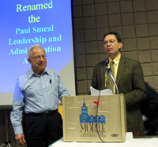
John Clark, Chair Executive Committee, announces the Paul Smeal Leadership and Administration Award

Meeting Recap
The Southern Region of the American Society for Horticultural Science met in conjunction with the Southern Association of Agricultural Scientists in Mobile, AL on February 3-5, 2007. The meetings were held in the River View Plaza Hotel, and the posters were in the adjacent Convention Center. The River View Hotel was under construction and change of ownership, which lead to many difficulties starting with room registration and continuing with inconveniences associated with construction and noise. It is likely that the members will not be in favor of going back to Mobile any time soon. However, one bright spot was that we were able to attend the Mobile Mardi Gras parades right outside the hotel. Mobile claims to be the site of the original Mardi Gras.

Pre-Registration was a Success. This was the first Southern Region meeting that allowed pre-registration by mail and on-line.

 | Registered | Pre-Registered
 | On-site | On-line | Mail
Professional | 53% | 39% | 8%
Graduate | 49% | 49% | 2%
Undergrad | 68% | 6% | 26%

Roughly half of the Professional (faculty, industry, etc.) and Graduate Students pre-registered. The Undergraduate Students favored registration on-site; probably because many do not know if they will attend until the last minute. Pre-registration by mail was the least popular; hence mail pre-registration may be discontinued in the future.

Payment by Credit Card. This was the first year the Southern Region allowed payment by credit card. We must thank Mike Neff for offering this service. Payment by credit card was very popular.

 | Payment Type
 | Cash | Credit Card
On-Site | 61% | 49%
Pre-Register | 19% | 75%

Next Year: On-Line Pre-Registration and On-Site Credit Card Payment Strongly Encouraged. The Secretary-Treasurer really really likes (yes, really was typed twice on purpose) pre-registration and on-site credit card payment. In fact, the Secretary-Treasurer would like even more usage of credit card payments. Why? Because, of the $6,920 collected on-site, $3,400 was cash, and the Secretary-Treasurer does not like to be responsible for that much cash!!!!! Heck, some of you might be tempted to knock him in the head next year now that you know how much cash he’s transporting! For these reasons, pre-registration and on-site credit card payment is going to be strongly recommended next year. This year there was no penalty for cancellation of on-line pre-registration, even if cancellation was up to the time of the meeting. Therefore, there is absolutely no disadvantage of pre-registering on-line using a credit card.

Attendance. The attendance was a bit lower than the 2006 Orlando meetings, mainly due to greater attendance of undergraduate students in Orlando. As usual, there was a strong showing of affiliated research, commodity, and administrative Working Groups. These are a vital component of the “networking” at the meeting.

The following table summarizes registration, paper presentations, and ACB judging teams.
 | Number
Professional (faculty,industry, etc.) | 131
Graduate Students | 43
Undergraduates | 31
Total Registration | 205
Oral Papers | 61
Posters | 31
Undergraduate Competition Papers | 4
Masters Competition Papers | 12
Ph.D. Competition Papers | 6
Total Papers/Posters | 114
Working Groups | 8
ACB Judging Teams | 6

Report from Headquarters
Dr. Randy Woodson, President ASHS, and Mike Neff, Executive Director of ASHS, attended the meeting. Dr. Woodson gave a status report of the national society.

Reflection on Deceased Members
The following members of Southern Region passed-away over this past year. Please reflect in your own way on their passing. Please notify Reed of others of which you may be aware, and of any passing in the future.

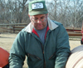 | Bruce Bostian  Oklahoma State University
 | Carl Campbell  University of Florida
Picture not available | Townsend Pope  North Carolina State University
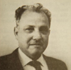 | Norman Maxwell  Texas A&M University
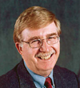 | Doug Sanders  North Carolina State University
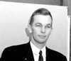 | Jake Tinga  Auburn University
Picture not available | Max Vines  University of Florida

Association of Collegiate Branch
The ACB had a very productive meeting. Saturday morning the ACB clubs gathered and shared club activities. Each club presented a PowerPoint presentation of their various activities over the past year. This is an excellent way for ideas to be shared. The Murray State Horticulture Club was selected to receive the Club Share Award for the best Club Share presentation.

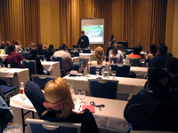
During Club Share, each ACB Club presents their yearly activities.

Saturday afternoon the clubs visited Flowerwood Nursery in Mobile. Mr. Jim VanAntwerp led the tour. Jim was an ACB member when he was an undergraduate student at Texas A&M University.

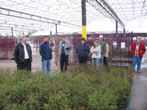
Mr. Jim VanAntwerp leads the ACB students on a tour of Flowerwood Nursery.
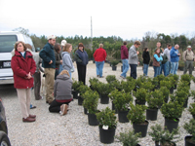
Students touring container field production.

On Sunday Monica Robinson, ACB President, chaired the J.B. Edmond Undergraduate Paper Competition. In the afternoon the clubs participated in an outstanding J. Benton Storey Horticulture Judging Contest.

ACB officers and faculty advisors setup and scored the entire contest in one day. This would not be possible without a group of dedicated advisors and students. Special thanks is extended to the ACB Advisor, Dr. Kim Pittcock, the “faculty regulars”, Kris-Ann Kaiser, Drs. Janet Cole, Mike Arnold, Richard Harkess, David Creech, Jim Robbins, Leo Lombardini and the ACB Officers, Monica Robinson, William Criner, Erica Hunt and L.B. Martin. Finally, a very special thanks is extended to Dr. J. Benton Storey for his continued monetary support of the contest.

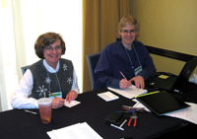
ACB Advisor Dr. Kim Pittcock and Dr. Janet Cole scoring the contest

Each ACB Club designates 4 individuals to form a judging team to compete for team awards. Six teams participated. In addition, all the other students compete as individuals. This allows all students in attendance to compete in the judging contest.

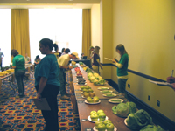
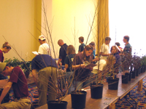
Scenes from the J. Benton Storey Horticulture Judging Contest

On Monday the clubs held their annual ACB Business Meeting and elected a new slate of officers for 2007.

President
Susan Murphy
Murray State University
Vice-President
James Plyler
Texas A&M University
Secretary
Stephen Blanchette
Murray State University
Treasurer
Mark Cooper
Mississippi State University
ACB Representative
Monica Robinson
Texas A&M University
Newsletter Editor
Laura McDonald
Oklahoma State University
ACB Faculty Advisor
Dr. J. Kim Pittcock
Arkansas State University

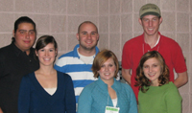
Newly elected ACB Officers for 2007-08.
Left to right back: James Plyler Vice-President, Stephen Blanchette Secretary, Mark Cooper Treasurer; left to right front: Laura McDonald Newsletter Editor, Susan Murphy President, Monica Robinson ACB Rep.

At the ACB Business Meeting, the Outstanding Club Award and Hammett Outstanding Club Member Awards were presented.

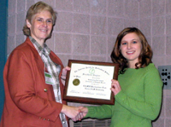
Outstanding ACB Club Award
TAMU Horticulture Club
Texas A&M University
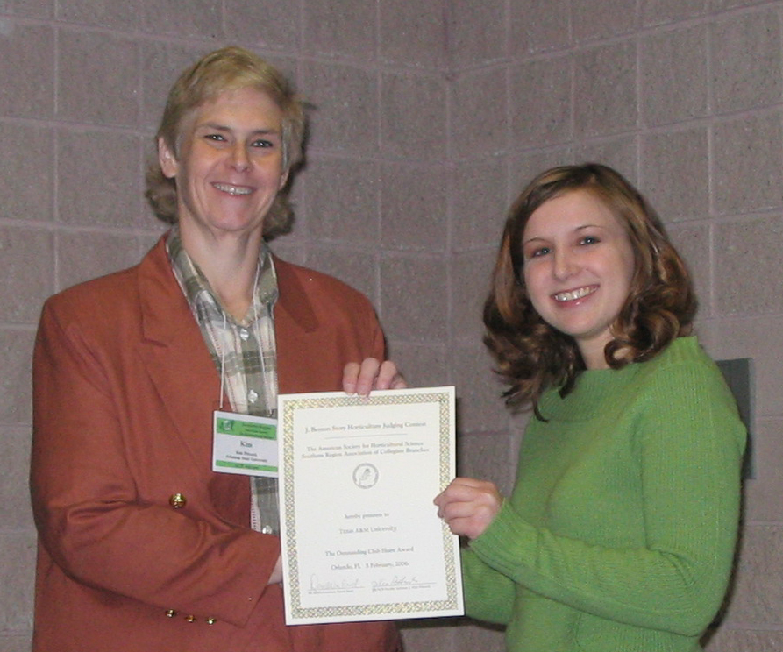
Hammett Outstanding ACB
Club Member Award
Monica Robinson
Texas A&M University

Fall 2006 Election Results
Officers and Section Chairs
The following were elected in the Fall 2006 elections.
President-Elect-Elect (presides over 2009 meeting)
Doug Bailey, GA
Executive Committee
Richard Harkess, MS (term begins 2007)
Cynthia McKinney, TX (term begins 2008)
Section Chairs-Elect-Elect (plans 2009 meeting)

Floriculture, Ornamentals and Turf
Ed Bush, LA

Vegetable Crops
Terry Kelley, GA

Fruit Crops
Eric Stafne, OK

Postharvest/Biotechnology
Elizabeth Baldwin, FL

Posters
Christine Coker, MS

Education

Brian Kahn, OK

Extension
David Lockwood, TN

Call for 2007 Dues
To determine if your 2007 dues are due, check the Online SRASHS Directory (http://srashs.org/MembershipDirectory/directory.html). It is up-to-date for dues paid at the Mobile meetings or dues paid through ASHS up to the end of March 2007. If your dues are due, they can be paid in one of the following three ways.
Payment Online (preferable)
1) Online when you renew your ASHS Membership, or
2) Through the ASHS Online Store (http://ashs.org/shop/home.php?cat=263)
Payment by Mail:
3) Mail the form at the end of the Newsletter along with a check (your cancelled check will be your receipt) to the Secretary-Treasurer.
Yearly dues: $20
Make checks payable to: Southern Region ASHS

Changing of the Guard
John Clark, Chair of the Executive Committee, presented retiring President Scott NeSmith with his Presidential Plaque and Gavel.

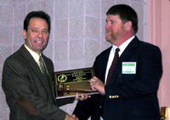
Retiring President Scott NeSmith receives Presidential Plaque and Gavel

Out-going President Scott NeSmith passes the “Andy Anderson Gavel” to in-coming President Penny Perkins-Veazie. President-Elect Penny Perkins-Veazie adjourns the Annual Business Meeting.

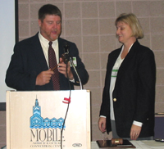
Incoming President Penny Perkins-Veazie receives “Andy Anderson Gavel” to adjourn the 2007 Annual Business Meeting.

Dallas 2008
2008 Annual Meeting
Southern Region ASHS
Dallas, Texas
February 2-5, 2008

Early Bird Information
Go to the SAAS web site for information about hotels and local attractions. The hotel rates are very economical ($99-$119). Dallas is loaded with things to do.
http://saasinc.org/2008-Dallas/Dallas2008-Main-pg.asp

Southern Region ASHS Awards

Member Awards

J. Creighton Miller, Jr.  Distinguished Educator Award |  |  | Krezdorn Award for  Excellence in Doctoral Research
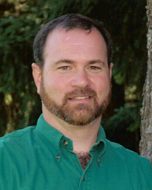 | Dr. Richard Harkess  Mississippi State University |  | 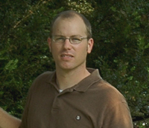 | Dr. Richard Olsen  University of Florida  (currently U.S. Arboretum)
Julian C. Miller, Sr.  Distinguished Research Award |  |  | John Hutchison  Young Extension Worker Award
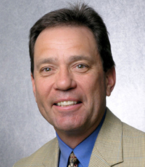 | Dr. John Clark  University of Arkansas |  | 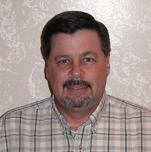 | Dr. Russ Wallace  Texas A&M University
Henry M. Covington Extension Award |  |  | Paul Smeal  Leadership and Administration Award
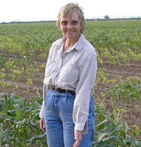 | Dr. Mary Lamberts  University of Florida |  | 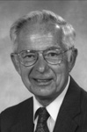 | Dr. Paul Smeal  Virginia Tech University, Emeritus

Graduate Student Paper Awards

Norman F. Childers  M.S. Graduate Student Paper Award  1st Place |  |  | Warren S. Barham  Ph.D. Graduate Student Paper Award  1st Place
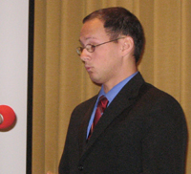 | Peter Dittmar  North Carolina State U.  Utilization of Commercially Available Pollenizers for Optimizing Triploid Watermelon Production |  | 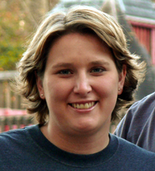 | Cheryl Boyer  Auburn University  Effect of Fertilizer Rate and Clean Chip Residual Substrate for Container-Grown Perennials
2nd Place |  |  | 2nd Place
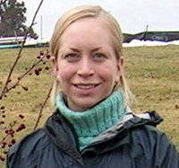 | Alexis Alvey  Virginia Tech University  Staking, Guying, and Root Ball Anchoring: The Efficacy of Tree Stabilization Systems Installed on Recently Transplanted Trees |  | 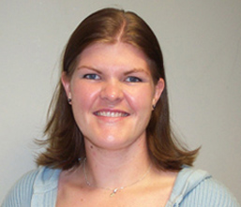 | Jennifer Waters  Texas A&M University  Semi-Quantitative Measurement of Carotenoid Development in Four Watermelon Colors: A Discussion of the Impact of Ploidy and other Genetic Factors
3rd Place |  |  | 3rd Place
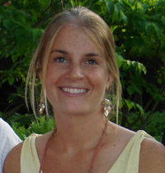 | Julie Guckenberger  Auburn University  Mulch type influences root growth of native woody shrubs |  | 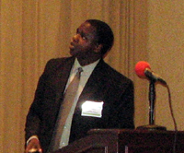 | D.W. Miano  Louisiana State University  Identification of molecular markers associated with sweetpotato resistance to sweetpotato virus disease

Undergraduate Student Paper Award
J.B. Edmond
Undergraduate Student Paper Award
1st Place
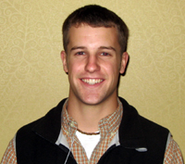 | David Warren  Clemson University  Landscaping for Water Quality: Designing a Demonstration Garden for the Friends of Lake Keowee Society Headquarters
2nd Place
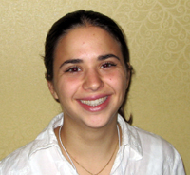 | Rachel Ben-Avraham  University of Florida  Nitrogen Mineralization in Greenhouse Turnips (Brassica campestris L.) Amended with Compost and Organic Fertilizer
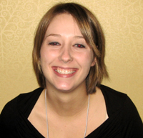 | Erin Cathcart  Murray State Univ.  Repellency Effects of Incorporated Worm Castings and Compost Tea Sprays on Whitefly Populations for Poinsettia Production (Euphorbia pulcherrima)

National Cowpea Improvement Association Poster Award
Best Graduate Poster
Graduate Student
Cheryl Boyer
Auburn University

Evaluation of Clean Chip Residual and Composted Poultry Litter as a Growth Substrate for Container-Grown Lantana camara

Extension Publications and Videos Blue Ribbon Winners

Janet Carson, Jim Robbins, Beth Phelps, Jennifer Vickery, Elizabeth Fortune, Chris Meux, Donna Rinke, Kevin Quinn and Bob Reynolds
Horticulture Highlights 2006

W.T. Kelley, E.G. Fonsah, A.N. Sparks Jr., D.B. Langston Jr., A.S. Culpepper, P.E. Sumner, K. Harrison, D.M. Granberry, G.E. Boyhan and W.C. Hurst
Commercial Pepper Production Handbook, Bulletin 1309

J.M. Kemble, E.J. Sikora, D. Fields, M.G. Patterson, and E. Vinson III
Guide to Commercial Sweetpotato Production in Alabama

Bert McCarty, Grady Miller, Clint Waltz and Trent Hale
Designing, Constructing, and Maintaining Bermudagrass Sports Fields

Thomas Yeager and Bart Schutzman
Florida Container Nursery BMP Guide

Association of Collegiate Branch Awards

Hammett Memorial Award for Outstanding ACB Member
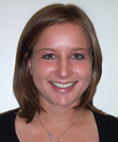 | Monica Robinson  Texas A&M University

Outstanding Collegiate Chapter Award
1st Place
Texas A&M University
2nd Place
Murray State University
3rd Place
Oklahoma State University

Collegiate Branch Judging Contest

Woody Ornamentals
Team
1st Place
Stephen F. Austin University
2nd Place
Texas A&M University
3rd Place
Murray State University
Individual
1st Place
Ellen Weatherholt
2nd Place
Christina Keim
3rd Place
Bo Spears

Greenhouse Floral & Foliage
Team
1st Place
Oklahoma State University
2nd Place
Texas A&M University
3rd Place
Stephen F. Austin University
Individual
1st Place
Annie Crockett
2nd Place
Ellen Weatherholt
3rd Place
Jon Pixler

Vegetable Crops
Team
1st Place
Murray State University
2nd Place
Texas A&M University
3rd Place
Oklahoma State University
Individual
1st Place
Justin Sparks
2nd Place
Shannon Slivinski
3rd Place
Elizabeth Pappenfort

Fruit and Nut Crops
Team
1st Place
Texas A&M University
2nd Place
Oklahoma State University
3rd Place
Murray State University
Individual
1st Place
John Gottula
2nd Place
Christina Keim
3rd Place
Adam Purrell

Overall
Overall Team
1st Place
Oklahoma State University
2nd Place
Texas A&M University
3rd Place
Stephen F. Austin University

Overall Individual
1st Place
Ellen Weatherholt
2nd Place
Justin Sparks
3rd Place
Laura McDonald

Minutes
Annual Business Meeting
Southern Region ASHS
February 5, 2007
Presidential Address: Dr. Scott NeSmith
President Scott NeSmith led the audience through a “Progression of Philosophy”. He started with the basic rules of “niceness” and manners that we learned in kindergarten, then how our views and actions have changed as we progressed through political correctness, the school of hard-knocks, day-to-day on the job, and leadership and team building training. He finally concluded that “All I Ever Really Needed to Know I Learned in Kindergarten”!

Annual Business Meeting: Dr. Scott NeSmith, President
I. Call to Order
II. Recognition of Special Guests
Randy Woodson, President ASHS, Mike Neff, Executive Director ASHS, Mark Legendre, Executive Director SAAS
III. Moment of Silence for Deceased Members
There was a moment of silence for the following members of the Southern Region who passed away in the past year or so.
Bruce Bostian, Oklahoma State University
Carl Campbell, University of Florida
Townsend Pope, North Carolina State University
Norman Maxwell, Texas A&M University
Doug Sanders, North Carolina State University
Jake Tinga, Auburn University
Max Vines, University of Florida
IV. Adoption of Minutes of 2006 Annual Meeting, Orlando, FL
The 2006 Minutes were corrected for misspelling of Steve E. Izekor, and then passed unanimously.
V. Financial Report: Dr. David Reed. (See Financial Report)
VI. Standing Committee’s Reports:
a. Executive Committee: Dr. John Clark, Chair. (See Executive Committee Minutes)
b. Nominations/Elections: Dr. Janet Cole, Chair
Introduction of New Officers (See Election Results Fall 2006)
Officers & Chairs Until 2009 (See Officers/Chairs table)
c. Membership: Dr. David Reed (See Membership Report)
VII. ASHS Report: Dr. Randy Woodson, President
Dr. Woodson gave a state of ASHS report.
- SAAS Report: Dr. David Reed
Upcoming meetings are scheduled for Fort Worth 2008, Atlanta 2009 and Orlando 2010.
- ACB Report & Introduction of New Officers: Ms. Monica Robinson, ACB President
a. Introductions of New Officers and Section Chairs
New Officers and Section Chairs present were introduced.
b. Introduction of ACB Officers: Monica Robinson, ACB President
The 2007 ACB Officers were announced (See 2007 ACB Officers)
IX. Old Business: none
X. New Business: none
XI. Other: none
Presentation of Andy Anderson Gavel to President-Elect
Adjourn – Penny Perkins-Veazie, President -Elect
Financial Report – 2006
Southern Region ASHS

 | Checking Account Balance 2/1/06 |  |  | $ -
Income: | Donations (Awards & Contests) |  | $ 2,300.00
 | Dues |  | $ 4,628.00
 | Interest |  | $ -
 | Registration |  | $ 80.00
 | Transfers from National Bank |  | $ 41,787.88
 |  | Total Income | $ 48,795.88 | $ 48,795.88
Expenses: | Abstract Publication |  | $ 1,320.00
 | Accounting |  | $ -
 | Association of Collegiate Branch |  | $ 600.00
 | Awards |  | $ 97.00
 | Clerical |  | $ 492.00
 | Contributions |  | $ 100.00
 | Meeting Expenses |  | $ -
 | Office Supplies |  | $ 96.30
 | Postage |  | $ 1,717.30
 | Printing and Reproduction |  | $ 592.65
 | SAAS Registration Fees |  | $ -
 | Secretary - Treasurer Travel |  | $ -
 | Web Site |  | $ 616.54
 | Transfer Out to CD's |  | $ 40,000.00
 |  | Total Expenses | $ 45,631.79 | $ 45,631.79
 | Checking Account Balance 12/31/06 |  |  | $ 3,164.09
 | Certificates of Deposits (Figures from 02/06 to 12/06 bank statement)
 | CD Number | Amount | Interest 2006
 | Society Funds
 | 0902002945 | $ 10,261.86 | $ 261.86 | Society Funds
 | 0902002953 | $ 10,261.86 | $ 261.86 | Society Funds
 | 0902002961 | $ 10,261.86 | $ 261.86 | Society Funds
 | 0902002988 | $ 10,261.86 | $ 261.86 | Society Funds
 | Sub-Total | $ 41,047.44 | $ 1,047.44
 | Endowments
 | 0902002112 | $ 5,277.08 | $ 203.92 | Miller Researcher
 | 0902002090 | $ 5,306.00 | $ 205.03 | Miller Educator
 | 0902002074 | $ 16,440.28 | $ 635.29 | Edmond UG Paper
 | 0902002104 | $ 5,497.39 | $ 212.43 | Barham PhD Paper
 | 0902002082 | $ 8,493.63 | $ 328.21 | Covington Extension
 | Sub-Total | $ 41,014.38 | $ 1,584.88
 | Total | $ 82,061.82 | $ 2,632.32
(Prepared and Reconciled by Gina Greig, Accountant)

Minutes
Executive Committee
Southern Region ASHS
February 3, 2007

Minutes
Executive Committee Meeting
Southern Region American Society for Horticultural Science
February 3, 2007
Presiding: John Clark, Chair

Committee Members Invited Guests
John Clark, ‘07 Scott NeSmith, President, ‘06
Joe Kemble, ‘08 Monica Robinson, ACB President, ‘06
Mike Arnold, ‘09 Kim Pittcock, ACB Advisor, ’06-08
Charles Gilliam, ’10 David Reed, Secretary-Treasurer, ‘06
Richard Harkess, ’11 Mike Neff, Executive Secretary, ASHS
David Creech, ‘12
Penny Perkins-Veazie, President-Elect

I. Call to Order
II. Adoption of Minutes of 2006 Annual Meeting, Orlando, FL - approved
III. Collect Names of Deceased Members
Doug Sanders, North Carolina State University
Carl Campbell, University of Florida
Townsend Pope, North Carolina State University
Max Vines, University of Florida
Norman Maxwell, Texas A&M University
Bruce Bostian, Okalahoma State University
V. Appointments:
a. Secretary-Treasurer:
David Reed was appointed for 2007-2008
b. Nomination/Elections Committee: appoint 3
The following were nominated, and will be contacted to the Secretary to determine which are willing to serve.
Craig Yencho (vegetable), NC State
Teddy Morelock (vegetables), U. Arkansas
Jim Ballington (fruit), NC State
Rick Snyder (vegetables), Mississippi State
c. ACB Advisor:
Cynthia McKenney (Texas Tech) and Leo Lombardini (Texas A&M) were mentioned as individuals that might be willing to serve. Kim Pittcock, current ACB Advisor, was asked to approach both and determine which was the most interested in serving.
VI. Secretary-Treasurer Report: David Reed
David Reed, Secretary Treasurer, reviewed the budget report and membership report that will be included in the Annual Business Meeting. He stressed the need to update the Constitution and By Laws to agree with certain current practices and add several items of clarification.

VII. SAAS Report: Dr. David Reed
David Reed reported that he and Scott NeSmith would attend the SAAS Business Meeting and make a report at the SRASHS Annual Business Meeting on Monday.
VIII. ACB Report: Ms. Monica Robinson, ACB President
Monica Robinson, current ACB President, gave and update on the activities, including the Club Share Program and field trip to Flowerwood Nurseries. She requested the half of the student registration fees collected be allocated to cover ACB expenses. The Board unanimously approved the request.
IX. Old Business:
- Motion from 2006 Executive Meeting:
In 2006, the Executive Committee approved that the election process for SR-ASHS be adjusted so that only the President-Elect, Section Chairs, and Executive Committee be elected, and that the President appoint members to awards committees.
Suggestion: To assist the President the Newsletter will contain a call for volunteers to serve on the various committees.
X. New Business:
a. Define “Active” member for the purpose of Awards
The Executive Committee discussed the need to define an active member for the purpose of awards. In the past, faculty have been nominated for awards who have never been a dues paying member of SRASHS, or has not paid dues for several years. All awards specify that recipients must be active members of SRASHS. The Executive Committee approved the following as the definition of Active Member:
Active Member: A member who has paid dues for the current year and 3 of the last 5 years.
b. Invited speakers and complementary registration
Sections and Working Groups often invite speakers to their sessions, and there is an expectation that they will not have to pay meeting registration fees. The Executive Committee discussed the need to develop the following guidelines for complementary registration for invited speakers:
Invited Speaker Complementary Registration:
- invited by a Section or Working Group Chair
- the Secretary-Treasurer is notified of the invitation
- the speaker is not a current dues paying member of SRASHS, and has not paid in the past 5 years.
- the speaker would not normally attend the SRASHS meetings, and has not attended in the past 5 years.
- Suggested revisions to Constitutions and By-Laws
The following Articles and Sections of the Constitution and By-Laws changes were suggested by the Executive Committee. An explanation of each is given. The Secretary-Treasurer was instructed to word smith the current Constitution/By-Laws to develop a mark-up draft; distribute draft to Executive Committee for input, develop final draft for distribution next fall for a vote by the membership at the 2008 Business Meeting.
Suggested revisions to Constitution or By-Laws?
Article V. Currently we elect Chairs-Elect-Elect, whereas the Article specifies that Chairs are to be Chairs Elect, and only the President is Elect-Elect. It was decided to leave the Article as is and to start following the Article in practice.
Article VI. 2. Change to return ballots to Nominations Chair not Secretary-Treasurer, which is the current practice.
Section 1 Change Floriculture and Ornamentals to Floriculture, Ornamentals and Turf to agree with the currently used name of the Section.
Section 2. Remove the wording that specifies the number of members from each commodity area to simply read six at large members. The Executive Committee is seldom in compliance with the current wording. The goal is for the Executive Committee to represent a cross-section of the society, but also to be composed of the active and interested members. In addition, term limit is recommended to be changed form 6 years (a new member elected each year) to 3 year terms (2 new members elected each year). Why? 6 years to too long!
Section 3. Rename the Nominating Committee to the Nominations and Elections Committee.
Section 4. It is recommended that this section be eliminated and the Membership Committee dissolved. In practice, the current process only represents one institution per state. In this day of electronic communication, the Secretary-Treasurer will ask that the administration of the Horticultural Administrators Working Group submit to the Secretary-Treasurer the names of all new faculty hires.
Section 5. It is recommended that this Section and the Awards Committee be eliminated. Each award has its own committee; hence there is no need for an “umbrella” awards committee.
Section 6. It is recommended that this Section and the Program Committee by eliminated. The society has never formed a Program Committee; rather the Secretary-Treasurer develops the program with input from Section and Working Group Chairs.
Section 7. Change the title to Ad Hoc Committees. Thus, this will allow the formation of Membership, Awards, Program, etc. Committees if needed. This is important if Section 4, 5 and 6 are eliminated.
Section 9 Eliminate the last phrase about dues in arrears after July. The dues period will be for the entire calendar year, and they can be paid at any time to become an active member. Thus, any dues collected will be for the calendar year in which they are collected, and one will declared an active member for that year.
Possible item to be added to Constitution or By-Laws?
Article VI.3. Method to replace elected Officers and Chairs. Currently, the position is left vacant until the next election. A section will be added to specify that vacancies will be replaced by the Executive Committee
- Adjourn – Penny Perkins-Veazie, President –Elect

Membership Report
Southern Region ASHS

State | 2006 | 2005 | 2004 | 2003 | 2002 | 2001 | 2000 | 1999 | 1998 | 1997 | 1996
Alabama | 24 | 32 | 25 | 24 | 26 | 23 | 29 | 31 | 34 | 44 | 43
Arkansas | 16 | 22 | 23 | 23 | 24 | 21 | 17 | 24 | 44 | 30 | 25
Florida | 50 | 41 | 51 | 56 | 54 | 49 | 55 | 51 | 59 | 70 | 74
Georgia | 32 | 36 | 35 | 43 | 49 | 51 | 53 | 44 | 52 | 43 | 52
Kentucky | 9 | 3 | 9 | 8 | 10 | 13 | 18 | 12 | 16 | 12 | 16
Louisiana | 21 | 22 | 27 | 27 | 24 | 22 | 24 | 29 | 42 | 36 | 34
Mississippi | 20 | 19 | 18 | 22 | 21 | 24 | 19 | 25 | 31 | 37 | 24
N. Carolina | 36 | 43 | 41 | 48 | 49 | 43 | 57 | 49 | 49 | 48 | 69
Oklahoma | 26 | 28 | 28 | 27 | 30 | 30 | 33 | 29 | 45 | 42 | 38
S. Carolina | 17 | 25 | 21 | 26 | 25 | 27 | 29 | 34 | 38 | 32 | 44
Tennessee | 18 | 19 | 17 | 16 | 21 | 29 | 32 | 29 | 24 | 29 | 29
Texas | 38 | 48 | 46 | 48 | 55 | 50 | 53 | 57 | 76 | 64 | 71
Virginia | 6 | 8 | 12 | 13 | 20 | 23 | 26 | 26 | 25 | 32 | 31
W. Virginia | 0 | 0 | 0 | 0 | 0 | 0 | 0 | 0 | 0 | 0 | 1
Out of Region | 15 | 16 | 15 | 19 | 20 | 18 | 18 | 24 | 23 | 20 | 21
Total | 328 | 362 | 368 | 400 | 428 | 423 | 463 | 464 | 558 | 539 | 572
 | Previous Years - Total Membership
 | 1995 | 1994 | 1993 | 1992 | 1991 | 1990 | 1989 | 1988 | 1987 | 1986 | 1985
 | 539 | 560 | 478 | 455 | 439 | 457 | 380 | 414 | 414 | 425 | 404
 | 1984 | 1983 | 1982 | 1981 | 1980 | 1979
 | 406 | 437 | 485 | 515 | 508 | 504

Call for 2007 Dues & Member Info
Southern Region ASHS

Dues
To determine if your 2007 dues are due, check the Online SRASHS Directory (http://srashs.org/MembershipDirectory/directory.html). It is up-to-date for dues paid at the Mobile meetings or dues paid through ASHS up to end of March 2007. If your dues are due, they can be paid in one of the following three ways.
Payment Online (preferable)
1) Online when you renew your ASHS Membership, or
2) Through the ASHS Online Store (http://ashs.org/shop/home.php?cat=263)
Payment by Mail (If necessary):
3) Fill-out and mail the following form, along with a check (your cancelled check will be your receipt) to the Secretary-Treasurer.
Yearly dues: $20
Make checks payable to: Southern Region ASHS

Corrections/Update Membership Directory Information
Check: _____ Member _____ Graduate Student _____ Undergraduate Student
Name
First Middle Last
Title
Department
University or Organization
Address 1
Address 2
City
State Zip
Phone FAX
E-Mail
Return to: (mail, fax or email form; mail dues)
David Wm. Reed
Secretary-Treasurer SRASHS
Dept. Horticultural Sciences
Texas A&M University
College Station, TX 77843-2133
FAX: 979-845-0627
E-Mail: dwreed@tamu.edu

2008 Officers, Chairs and Committees
Southern Region ASHS

Offices
President (elected) | Penny Perkins-Veazie
Secretary-Treasurer (appointed by Executive Com.) | David Reed
Executive Committee (elected for progressive 6 year term)
Chair | Joe Kemble
Member | Mike Arnold
Member | Charles Gilliam
Member | Richard Harkess
Member | David Creech
Member | Cynthia McKenney
Member, President-Elect | Doug Bailey
Nominating Committee
Chair, Senior Retired President | David Reed
Member, Immediate Past President | Scott NeSmith
Member (2-yr term, appointed by Executive Com). | appoint (08-09)
Member (2-yr term, appointed by Executive Com). | appoint (08-09)
Member (2-yr term, appointed by Executive Com). | Richard Harkess
Member (2-yr term, appointed by Executive Com). | replace
Section Chairs (Elected)
Education Section | Amy Wright
Extension Section | Kathryn Taylor
Floriculture, Ornamentals and Turf Section | Wayne Mackay
Fruit Crops Sections | Steve Stringer
Poster Section | Bodie Pennisi
Postharvest/Biotechnology Section | Niels Maness
Vegetables Crops Section | Lynn Brandenberger
Collegiate Branch | Todd Cavins
Paper Competition Chairs (Elected/Appointed)
J.B. Edmond Undergraduate Student Paper Comp.
ACB President (Moderator) | Susan Murphy
Chair (Judge Coordinator) | Todd Cavins
SRASHS President (Introduces Session) | Penny Perkins-Veazie
Norm F. Childers M.S. Graduate Student Paper Comp. | Doug Bailey
Warren S. Barham Ph.D. Graduate Student Paper Comp. | Doug Bailey

Awards Committees (appointed for 3-year progressive term)
J. Creighton C. Miller, Jr. Distinguished Educator Chair | David Picha
Member | James Gibson
Member | Appoint/Volunteer
Julian Miller, Sr. Distinguished Research Chair | James Spiers
Member | Patricia Knight
Member | Appoint/Volunteer
Henry M. Covington Extension Award Chair | George Boyhan
Member | Jonathan Schulthesis
Member | Appoint/Volunteer
John E. Hutchinson Young Extension Worker Chair | Stephen Olson
Member | Paul Thomas
Member | Appoint/Volunteer
Krezdorn Excellence in Doctoral Research & Writing Chair | Jim Ballington
Member | Teddy Morelock
Member | Appoint/Volunteer
Smeal Leadership and Administration Chair | Janet Cole
Member | David Reed
Member | Scott NeSmith
Blue Ribbon Extension Communication Chair | Alan Owens
Member | Elena Garcia
Member | Appoint/Volunteer
Outstanding ACB Club | Kim Pittcock
Hammet Memorial Outstanding ACB Member | Kim Pittcock
Research/Working Group Chairs
Watermelon Research Group | Steve King
National Cowpea Improvement Association | Bill Gebhardt
Pecan Research & Extension Forum | Leo Lombardini
Sourthern Blueberry/Small Fruit Workers | Joe Masabni
Southern Region Small Fruit Consortium | Tom Monoco
Horticultural Administrators | David Williams
National Sweet Potato Colaborators | Zvesdana Pesic-VanEsbroeck
Southern Sweet Potato IPM Project | Jennifer Curtis
Cucurbit Crop Germplasm Committee
Vigna Crop Germplasm Committee | Richard Fery
Association of Collegiate Branch
President | Susan Murphy
Vice-President | James Plyler
Treasurer | Mark Cooper
Secretary | Stephen Blanchette
ACB Representative | Monica Robinson
Newsletter Editor | Laura McDonald
ACB Faculty Advisor (last year of 3-year term) | Kim Pitcock
Advisor-Elect (appointed in 2nd year) | Leo Lombardini

Call for Nominations/Volunteers
for Officers and Committee
Southern Region ASHS

Nominations/volunteers are needed for President, Executive Committee, Collegiate Branch Section Chair and Awards Committees. The President, Executive Committee, and Collegiate Branch Section Chair are elected positions. The Elections Committee will select two nominees to appear on the Fall 2007 Election Ballot. Awards Committee Chairs will be appointed by the President. You are encouraged to nominate/volunteer yourself. If you nominate someone else, make sure they agree.

Nominee for Elected Office

President:

Executive Committee:

Collegiate Branch Section Chair:

Nominee/Volunteer for Awards Committee

Krezdorn Doctoral Writing Award

Creighton Miller, Jr. Educator Award

Julian Miller, Sr. Researcher Award

Hutchinson Young Extension Award

Covington Extension Award

Blue Ribbon Communication Award

Sent in by: ________________________________

E-Mail, Fax or Mail to Either

David Wm. Reed Penny Perkins-Veazie
Chair, Awards Committee SRASHS President, SRASHS
Dept. Horticultural Sciences P.O. Box 159, Hwy 3 West
Texas A&M University ARS South Central Ag Research Lab
College Station, TX 77843-2133 Lane, OK 74555
Fax: 979-845-0627 Fax: (580) 889-5783
E-Mail: dwreed@tamu.edu E-Mail: pperkins-usda@lane-ag.org

