 | Post Convention Newsletter  Southern Region  American Society for Horticultural Science | 
Paul Smeal 66th Annual Meeting of the Southern Region American Society for Horticultural Science
April 2006

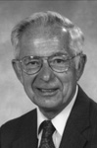 | RESOLUTION  In Honor of Paul Smeal  Secretary-Treasurer, 1990-2006  Southern Region of the  American Society for Horticultural Science
Whereas, Paul Smeal has a passion for the SR-ASHS; and
Whereas, Paul Smeal has served as Secretary-Treasurer of the SR-ASHS for 16 years; and
Whereas, Paul Smeal developed an effective working relationship with SAAS, which greatly benefited the SR-ASHS; and
Whereas, Paul Smeal was an excellent fiscal manager of SR-ASHS; and
Whereas, Paul Smeal was responsible for significant growth of endowments; and
Whereas, Paul Smeal’s organizational skills have allowed the SR-ASHS Annual Meeting to function efficiently and professionally; and
Whereas, Paul Smeal’s tireless commitment to recruiting and maintaining membership has allowed stability in the SR-ASHS; and
Whereas, Paul Smeal has been a strong supporter of the growth of the ACB; and
Whereas, Paul Smeal served as President of SR-ASHS in 1978, and of ASHS in 2001; and
Whereas, Paul Smeal has maintained the SR-ASHS as the most highly respected, attended, and active region of the parent society;
Be It Resolved, that in order to express its deepest appreciation and gratitude, the Executive Committee declares that the 2006 meetings will hence forth be called the

“Paul Smeal 66th Annual Meeting of the Southern Region
of the American Society for Horticulture Science”

Past Presidents of the
Southern Region of the American Society for Horticultural Science
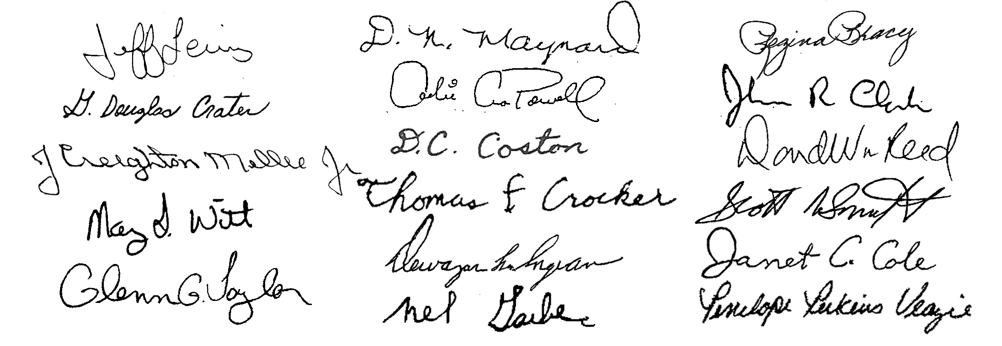

Paul Smeal Honored
Effective the end of the 2006 meeting, Paul Smeal retired as Secretary-Treasurer. Paul served tirelessly since 1990 and his leadership will be sorely missed. Paul was honored at both the SAAS and SR-ASHS business meeting. The SR-ASHS Executive Committee passed a resolution that the 2006 meetings will be officially declared the “Paul Smeal 66th Annual Meeting of the Southern Region of the American Society for Horticultural Science”. In addition, the Executive Committee invited Paul back to the 67th meeting in Mobile so that he can attend at least one meeting in a relaxed atmosphere.
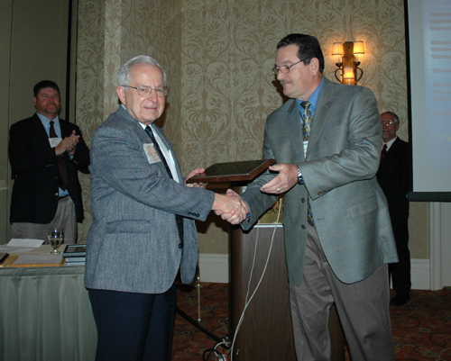
Dr. Paul Smeal receives resolution plaque from Dr. Jim Ballington, Chair Executive Committee

Reed Replaces Smeal

Dave Reed, Texas A&M University, was appointed Secretary-Treasurer to “replace” Paul. During his Presidential Address, Dave asked the membership to keep the following philosophy in mind when formulating their opinion as to whether or not he can actually “replace” Paul.
”If you keep your expectations low, you will never be disappointed”
Meeting Recap
The Southern Region of the American Society for Horticultural Science met in conjunction with the Southern Association of Agricultural Scientists in Orlando Florida, February 4-8, 2006. The meetings were held in the Wyndham Orlando Resort. Most of the meeting rooms were within very close proximity, and there were ample eateries within walking distance of the resort. The weather was cool, but nice. By all accounts it was a convenient and enjoyable meeting for most.

Attendance
The following table summarizes registration, paper presentations, and ACB judging teams.

 | Number
Members, Professionals | 153
Graduate Students | 21
Undergraduates | 49
Total Registration | 223
Oral Papers | 79
Posters | 33
Undergraduate Papers | 4
Masters Competition Papers | 7
Ph.D. Competition Papers | 3
Total Papers/Posters | 123
Working Groups | 8
ACB Judging Teams | 7

As usual, there was a strong showing of affiliated research, commodity, and administrative Working Groups. These are a vital component of the “networking” at the meeting.

Report from Headquarters
Dr. Paul Read, President ASHS, could not attend, but our very own Dr. Fred S. Davies represented President Read. Mike Neff, Executive Director of ASHS, attended the meeting and offered headquarters’ full support as we try to replace Paul. The “big news” is that Mike has offered headquarters’ resources to allow SR-ASHS to accept credit card payment of registration at next year’s annual meeting. We will also begin posting the newsletter on the ASHS web site, and over time will make more information available on-line. The current Southern Region URL on the ASHS web site is: http://ashs.org/regional/history.html
Reflection on Deceased Members
The following members of SR-ASHS passed-away over this past year. Please reflect in your own way in memory of their passing.

Booker T. Whatley
Tuskegee Institute
Steve Izekor
University of Arkansas, Pine Bluff
Wayne Bourgeois
Louisiana State University
Ray Worley
University of Georgia
Please notify Reed of others of which you may be aware, and of any passing in the future.

Association of Collegiate Branches
The ACB held a very productive meeting. On Saturday morning the clubs visiting the Epcot Center at Disney World and were given a behind the scenes tour.
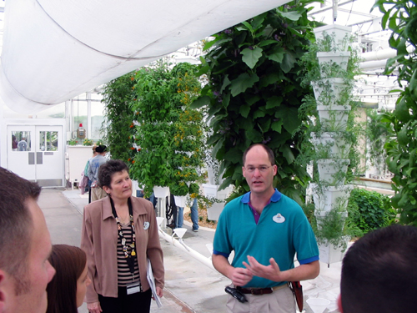Students and advisors on a behind the scenes tour at Epcot Center
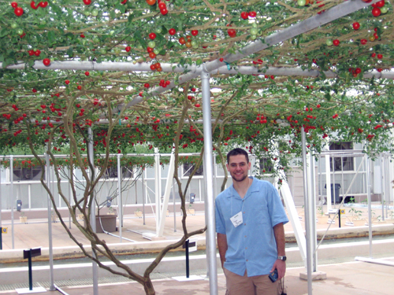
Student under the tomato tree at Epcot Center.
Later that day the clubs gathered and shared club activities. Each club presented a PowerPoint presentation of their various activities over the past year. This is an excellent way for ideas to be shared.

On Sunday Michael Boyd, ACB President, Chaired the J.B. Edmond Undergraduate Paper Competition. In the afternoon the clubs participated in an outstanding J. Benton Storey Undergraduate Judging Contest.

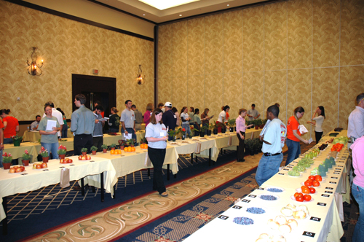
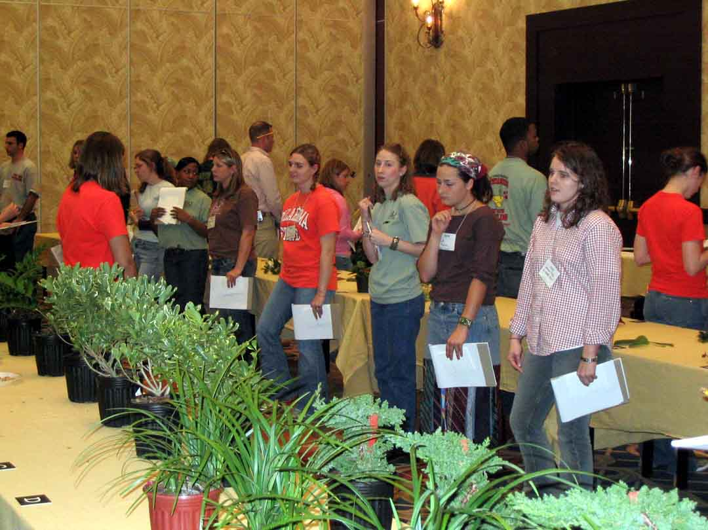
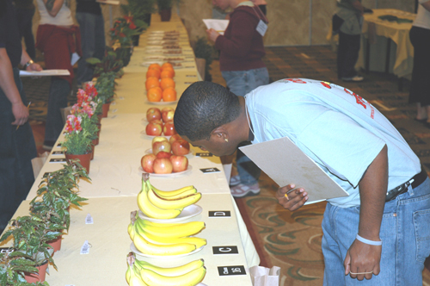
Scenes from the J. Benton Storey Undergraduate Student Horticulture Judging Contest

Faculty advisors and ACB Officers must setup and score the entire contest in one day. This would not be possible without a group of dedicated advisors and students. Special thanks is extended to the ACB Advisor, Dr. Kim Pittcock, the “faculty regulars”, Drs. Janet Cole, Mike Arnold, Richard Harkess, Brian Kahn, David Creech, and the ACB Officers, Mike Boyd, Amanda Churak, Elizabeth Wilson and Rachael Ramon. Finally, a very special thanks is extended to Dr. J. Benton Storey for his continued monetary support of the contest.

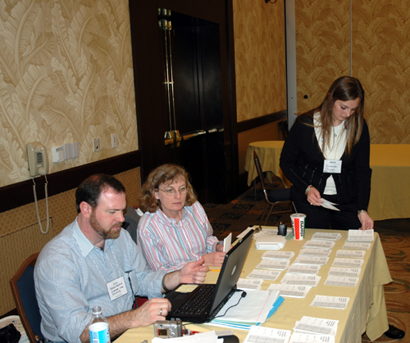
Dr. Richard Harkess, Dr. Janet Cole and Amanda Churak scoring judging forms.

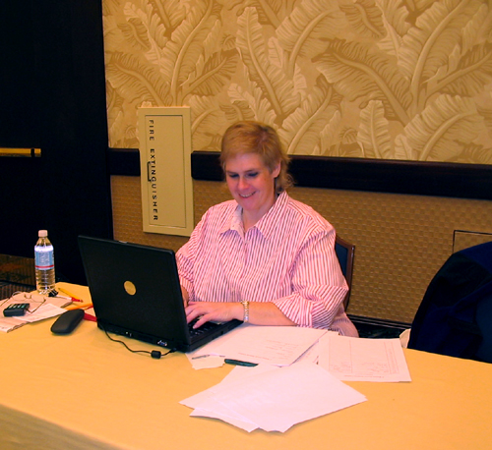ACB Advisor Dr. Kim Pittcock entering scores.

On Monday the clubs held their annual ACB Business Meeting and elected new officers for the upcoming year. The new officers were introduced at the society Annual Business Meeting and their names appear in the attached minutes.
Poster Session
The poster session was very successful. Thirty-three posters were exhibited. The posters for all agricultural disciplines in SAAS were located in the same room.
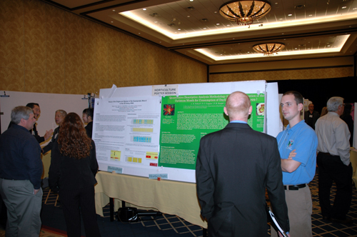The poster session generated extensive
one-on-one dialogue.

Changing of the Guard
Out-going President Dave Reed passes the “Presidential Andy Anderson Gavel” to in-coming President Scott NeSmith.

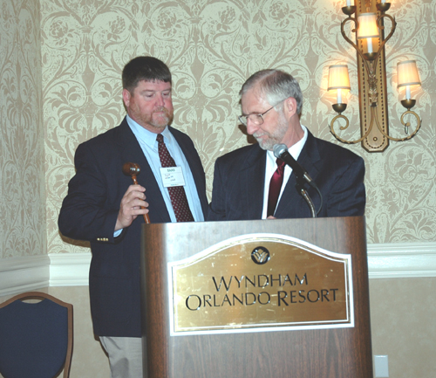
Out with the old and in with the new.

On To Mobile
2007 Annual Meeting
Southern Region ASHS
Mobile, AL
February 3-7, 2007

Early Bird Information
http://www.saasinc.org/Mobile2007/Mobile-Main-Pg.asp

SR-ASHS Awards
Southern Region ASHS

Member Awards

J. Creighton Miller, Jr.  Distinguished Educator Award |  |  | Krezdorn Award for  Excellence in Doctoral Research
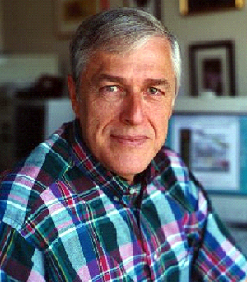 | Dr. Daniel R. Lineberger  Texas A&M University |  | 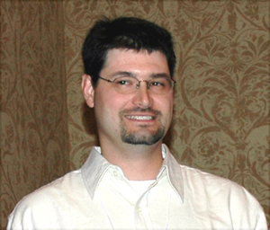 | Dr. Eric T. Stafne  Oklahoma State University
Julian C. Miller, Sr.  Distinguished Research Award |  |  | John Hutchison  Young Extension Worker Award
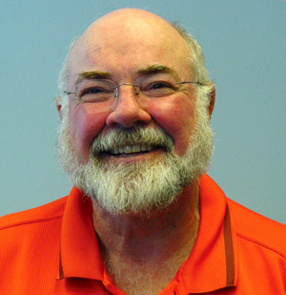 | Dr. Michael W. Smith  Oklahoma State University |  | not presented
Henry M. Covington Extension Award |  |  | Leadership and Administration Award
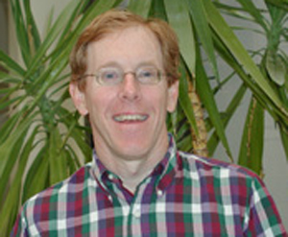 | Dr. James A. Robbins  University of Arkansas |  | 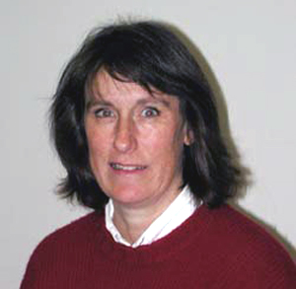 | Dr. Sylvia Blankenship  North Carolina State University

Graduate Student Paper Awards

Norman F. Childers  M.S. Graduate Student Paper Award  1st Place |  |  | Warren S. Barham  Ph.D. Graduate Student Paper Award  1st Place
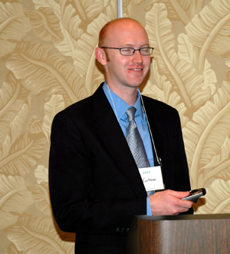 | Ryan Contreras  North Carolina State U.  Reproductive behavior of diploid and allotetraploid Azaleadendrons |  | 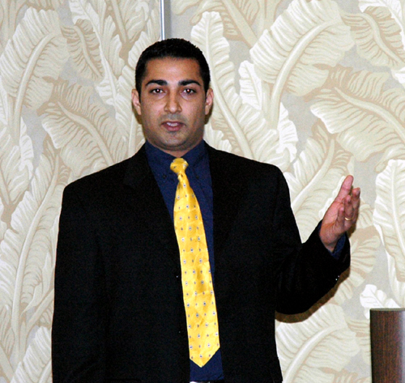 | Malkeet Padda  Louisiana State Univ.  Phenolic composition and antioxidant activity in sweetpotato root and leaf tissue at different developmental stages
2nd Place |  |  | 2nd Place
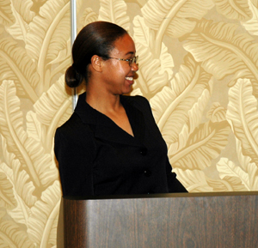 | Connie Johnson  Auburn University  Influence of substrates on rooting Clematis socialis stem cuttings |  | 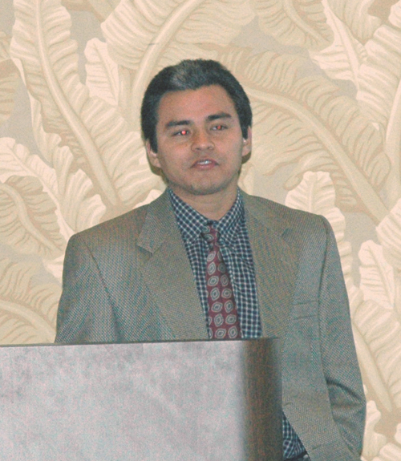 | Jim Cervantes-Flores  North Carolina State U.  Development of a genetic linkage map in sweepotato based on AFLP markers and QTL analysis of economically important traits
3rd Place |  |  | 3rd Place
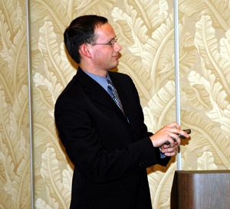 | Peter Dittmar  North Carolina State U.  Effects of post-application halosulfuron-methyl at various percents of coverage on watermelon |  | 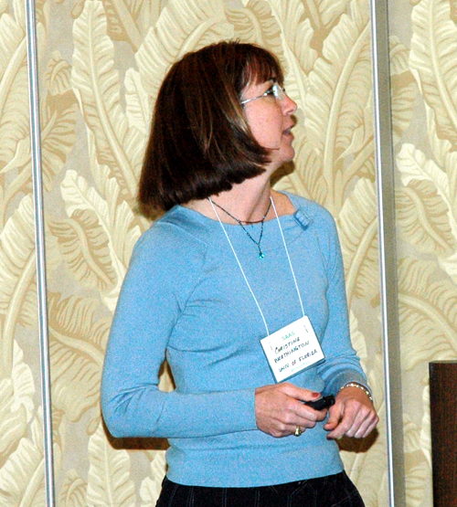 | Christine Worthington  University of Florida  Fate and movement of NO3-N as a result of staged leaching irrigation events and fertilizer source during potato production in northeast Florida

Undergraduate Student Paper Awards
J.B. Edmond
Undergraduate Student Paper Award

1st Place
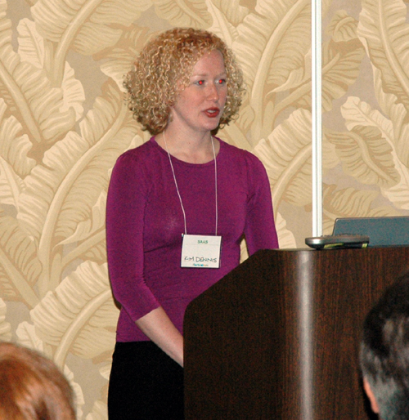 | Kimberly Dennis  University of Arkansas  Adventitious shoot propagation and cultural inputs on nursery production of a primocane-fruiting blackberry selection
2nd Place
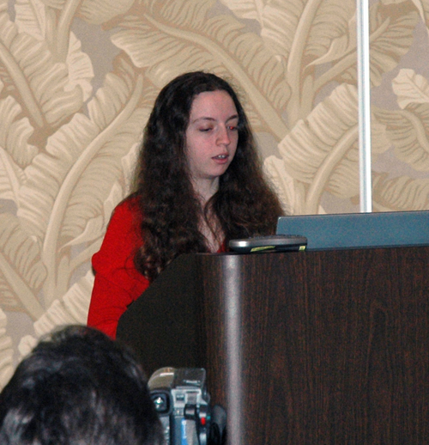 | Monica Haddix  North Carolina A&T State Univ.  In vitro shoot proliferation of Encyclia tampensis (Lind.) Orchids

National Cowpea Improvement Association Poster Award
Best Undergraduate Poster

Megan Ulmer
Tuskegee University
Study of the origins and spread of the sweetpotato weevil in the US using rDNA sequences

Extension Publications and Videos Blue Ribbon Winners

Marco Fonseca, Alfredo Martinez, Vincent Lopez and Gil Landry
University of Georgia
Landscape Safety Training Manual for Hispanic Workers

Gary Wade and Sharley Crisafulli
University of Georgia
Georgia Gold Medal Winners

Mike Schnelle, David Hillock, Jennifer Adsit, Gayle Hiner, Trish Gedon and Katie Reim
Oklahoma State University
Landscaping with Trees, Shrubs, and Vines in Oklahoma

Paul Thomas and Bodie Pennisi
University of Georgia
Annuals and Perennials for Georgia Gardens

Lenny Wells
University of Georgia
Mouse Ear of Pecan

Rick Snyder, David Ingram and Blake Layton
Mississippi State University and Experiment/Extension Centers
Greenhouse Tomato Growers’ Glossary

Association of Collegiate Branch Awards

Hammett Memorial Award for Outstanding ACB Member
Kimberly Lee
Arkansas State University

Outstanding Collegiate Chapter Award
1st Place
Texas A&M University Horticulture Club
2nd Place
Arkansas State University Plant Science Club
3rd Place
Murray State University Horticulture Club

Collegiate Branch Judging Contest

Woody Ornamentals
Team
1st Place
Louisiana State University
2nd Place
Texas A&M University
3rd Place
Mississippi State University
Individual
1st Place
Logan Barton
2nd Place
Travis Forman
3rd Place
Ellen Weatherholt

Greenhouse Floral & Foliage
Team
1st Place
Texas A&M University
2nd Place
Oklahoma State University
3rd Place
Mississippi State University
Individual
1st Place
Ellen Weatherholt
2nd Place
Laura Bible, Lindsey Rakowitz, Justin Sparks
3rd Place
Kara Smith

Vegetable Crops
Team
1st Place
Texas A&M University
2nd Place
Oklahoma State University
3rd Place
Louisiana State University
Individual
1st Place
Ellen Weatherholt
2nd Place
Jeremy Stavinoha
3rd Place
Christina Keim

Fruit and Nut Crops
Team
1st Place
Arkansas State University
2nd Place
Texas A&M University
3rd Place
Oklahoma State University
Individual
1st Place
Ann Fleener
2nd Place
Matt Quirey
3rd Place
Erica Hunt

Overall
Overall Team
1st Place
Texas A&M University
2nd Place
Oklahoma State University
3rd Place
Mississippi State University

Overall Individual
1st Place
Ellen Weatherholt
2nd Place
Logan Barton
3rd Place
Carina Haines

Minutes
Annual Business Meeting
Southern Region ASHS
February 6, 2006
Presidential Address - Dr. David Wm. Reed
A New Generation of “Clientele” is Emerging – the Millennials
The current Millennial Generation is composed of those individuals born since the 1980s and that have come of age at the turn of the millennium. They are beginning to enter colleges and universities in increasing numbers. They are the most protected generation in history and are hovered over by “helicopter parents.” The Millennial’s experiences, characteristics and expectations differ from the current generation (Baby Boomers and Generation X) of teachers, extension agents and researchers. These generational differences can “clash” and alter the “effectiveness” of classroom teaching, extension programming and graduate student training. “Effectiveness” will require the current generations to understand what motivates the Millennials, and we must “learn” how to “reach” and “teach” them. The complete presentation can be viewed at: http://hort201.tamu.edu/prof/Vita/VITA2005Jan.htm
Presiding: Dr. David Wm. Reed, President
I. Call to Order
II. Recognition of Special Guests
Dr. Fred S. Davies for Dr. Paul Read, President ASHS; Mr. Mike Neff, Executive Director, ASHS; Dr. Norm Childers; Past ASHS Presidents, Drs. Paul Smeal, Dan Lineberger, Don Maynard, and Fred S. Davies
III. Moment of Silence for Deceased Members
Booker T. Whatley, Tuskegee Institute; Sever Izakor, University of Arkansas, Pine Bluff; Wayne Bourgeois, Louisiana State University; Ray Worley, University of Georgia
IV. Adoption of Minutes of 2005 Annual Meeting in Little Rock, Arkansas
Published in Post Conference Newsletter, February 2005. Passed by consent
V. Financial Report: Dr. Paul L. Smeal. See the Financial Statement on the following pages
VI. Standing Committee’s Reports:
a. Executive Committee: Dr. James Ballington, Chair. See Executive Committee Minutes on the following pages
b. Nominations/Elections: Dr. John Clark, Chair
See Election Results Fall 2005 Officers, Section Chairs & Committee Members on the following pages
c. Membership: Dr. Paul Smeal. See Membership Report on following pages
VII. ASHS Report: Dr. Paul Read, President
Dr. Paul Read was out of the country, and Dr. Fred S. Davies gave a brief update of society news.
VIII. SAAS Report: Dr. David Reed
Dave Reed was elected a member-at-large of the SAAS Executive Committee. The Executive Committee is studying how to improve low attendance at the SAAS General Session.
The following meeting dates were confirmed:
2007 – Mobile, AL
2008 – Dallas, TX, Adams Mark Hotel
2009 – Looking into Lexington, Birmingham or Mobile
IX. Old Business: none
X. New Business:
a. Introductions of New Officers and Section Chairs
New Officers and Section Chairs present were introduced.
b. Introduction of ACB Officers: Mr. Michael Boyd, ACB President
See the Association of Collegiate Branch 2006 Officers on the following pages
XI. Other: none
Financial Report – 2005
Southern Region ASHS

Checking Account Balance, 1-1-2005 $3,628.23

Income: SR, ASHS Registration and SR dues 14,700.00
SR Dues 4,801.00
Awards 600.0
Interest on Certificates of Deposit 53.69
Total Income $20,154.69 $23,782.92

Expenses: Southern Region – ACB 970.00
Printing of 2004 Abstracts in HortScience 1350.00
Awards (cash awards $2700, certificates, etc.) 3,628.78
Office supplies, etc. 1,101.47
Copy/Printing (newsletter, envelopes, letters) 2,432.11
Postage 992.58
Secretary-Treasurer Travel/Expenses 1,189.72
SAAS Registration Fees 6,110.00
Telephone/Computer Time & Expenses 1,900.75
Meeting Expenses 693.11
Refund 85.00
Total Expenses $20,453.52 $20,453.52

Checking Account Balance, 12-31-2005 $3,329.30

Certificates of Deposits (Figures from 11/05 thru 12/02/05 bank statement)
CD Number Amount Interest Earned in 2005
338 3,385.36 71.23
389 3,385.36 71.23
353 4,373.41 126.91
354 3,220.72 93.46
905 9,302.07 168.29
098 4,911.73 91.53
137 15,823.87 879.09 J.B. Edmund Fund
364 5,298.92 115.34 Barham Ph.D. Fund
629 8,157.80 147.80 Covington Ext. Fund
640 5,092.37 92.37 J. Creighton Miller, Jr. Educator Fund
742 5,059.22 59.22 Julian C. Miller Research Fund

Total $39,422.18 $1,915.47

Prepared by Paul L. Smeal, Secretary-Treasurer, January 16, 2006

Minutes
Executive Committee
Southern Region ASHS
February 4, 2006

SR-ASHS Executive Committee Meeting
Saturday, February 4, 2006

The meeting was called to order by committee chair Jim Ballington.

Members and invited guests in attendance introduced themselves as follows:
Committee Members Invited Guests
Jim Ballington, 06, Chair David Reed, President
John Clark, 07 Paul Smeal, Secretary-Treasurer
Joe Kemble, 08 Michael Boyd, ACB President
Mike Arnold, 09 Kim Pittcock, ACB Faculty Advisor
Charles Gilliam, 10 Penny Perkins-Veazie, President-Elect
Scott NeSmith, President, 06 Mike Neff, ASHS Executive Director

David Creech, 12; new committee member after the 2006 meeting, was also present as a guest. Member Elizabeth Lamb, 11, was not present.

The names of SR-ASHS members who died during 2005 were announced as follows:
Wayne Bourgeois, LSU
Steve Izekor, Univ. Ark., Pine Bluff
Booker T. Whatley, Tuskagee Institute

David Reed was appointed as SR-ASHS Secretary-Treasurer for 2006 by unanimous vote. Jim Ballington then thanked Paul Smeal for his willingness to serve as Secretary-Treasurer for an additional year, while David was serving as SR-ASHS president.

Nominations/elections committee chair John Clark reported on the results of the 2005 election (already mailed to the membership).

John Clark also brought up the question of whether it is preferable to elect or appoint awards committees members. He noted the difficulties the nominations/elections members routinely encounter identifying nominees for awards committee membership.
Next followed a discussion as to whether the Bylaws of the SR-ASHS require election of awards committee members. Following review of Section 3 of the Bylaws it was determined that this was not the case. John Clark then presented the following motion:
“The election process for SR-ASHS be adjusted so that only the President-Elect, Section Chairs, and Executive Committee be elected, and that the President appoint members to awards committees.”
The motion was seconded by Joe Kemble and passed unanimously by show of hands.

The nominations/elections committee for 2006 includes Janet Cole, Chair, David Reed, and Janice Bohac; and Richard Harkess and Doug Sanders were nominated to fill the other two remaining slots on the committee. Both the nominees have agreed to serve.

Paul Smeal presented the Secretary-Treasurer’s report for 2005, which has also been sent to the membership. He also briefly reviewed the agendas for the business meeting and the awards program.

David Reed pointed out that he has changed to the Everbank on-line banking system which will make the finances of the organization easier to manage, and pays 3.0% interest on funds held in the checking account, so long as $1,500.00 remains in the account, and 4.5% interest on CD’s. He noted that the majority of the organization’s funds will remain in CD’s.

Michael Boyd, SR-ACB president, reported that the ACB members in attendance had a very interesting visit to EPCOT. Michael also made the formal request for the return of half the registration fees paid by ACB members to the ACB.
Mike Arnold made a motion to this effect, which was seconded by Joe Kemble and passed by show of hands.

The committee noted that appreciation needs to be expressed to Benton Storey for underwriting and establishing an endowment to cover the expenses for the ACB judging contests. David also directed the ACB to send a letter of appreciation to Dr. Storey.

The committee again expressed their appreciation to Creighton Miller for establishing and supporting the Julian C. Miller, Sr. Distinguished Researcher Award and the J. Creighton Miller, Jr. Distinguished Educator Award.

There was no SAAS report at the time of the meeting because the SAAS Broad meeting was not to take place until Sunday.

There was no new business or other items to consider and the meeting was adjourned.

Jim Ballington, Chair
SR-ASHS Executive Committee, 06

Election Results Fall 2005
Officers, Section Chairs & Committee Members
Southern Region ASHS

President-Elect
(term begins after 2007 meeting)

Penelope Perkins-Veazie, OK

Section Chairs-Elect, 2007
(will plan meeting for 2008)

Floriculture, Ornamentals and Turf
Wayne McKay, TX

Vegetables
Lynn Brandenberger, OK

Fruits
Steve Stringer, MS

Postharvest/Biotechnology
Niels Maness, OK

Posters
Bodie Pennisi, GA

Education
Amy Wright, AL

Extension
Kathryn Taylor, GA

J.B. Edmond Award- Collegiate Branches
Todd Cavins, OK (term until 2007)
Pat Williams, KY (term until 2008)

Executive Committee

Dave Creech, TX

Awards Committees

J. Creighton Miller, Jr. Distinguished Educator
James Gibson, FL

Julian C. Miller, Sr. Distinguished Research
Patricia Knight, MS

Henry M. Covington Extension Award

Jonathan Schultheis, NC

Excellence in Doctoral Research and Writing
Teddy Morelock, AR

John E. Hutchinson Young Extension Worker
Doug Sanders, NC

Extension Communications
Elena Garcia, AR

Membership Report
Southern Region ASHS

 | 10 Year History
State | 2005 | 2004 | 2003 | 2002 | 2001 | 2000 | 1999 | 1998 | 1997 | 1996
Alabama | 32 | 25 | 24 | 26 | 23 | 29 | 31 | 34 | 44 | 43
Arkansas | 22 | 23 | 23 | 24 | 21 | 17 | 24 | 44 | 30 | 25
Florida | 41 | 51 | 56 | 54 | 49 | 55 | 51 | 59 | 70 | 74
Georgia | 36 | 35 | 43 | 49 | 51 | 53 | 44 | 52 | 43 | 52
Kentucky | 3 | 9 | 8 | 10 | 13 | 18 | 12 | 16 | 12 | 16
Louisiana | 22 | 27 | 27 | 24 | 22 | 24 | 29 | 42 | 36 | 34
Mississippi | 19 | 18 | 22 | 21 | 24 | 19 | 25 | 31 | 37 | 24
N. Carolina | 43 | 41 | 48 | 49 | 43 | 57 | 49 | 49 | 48 | 69
Oklahoma | 28 | 28 | 27 | 30 | 30 | 33 | 29 | 45 | 42 | 38
S. Carolina | 25 | 21 | 26 | 25 | 27 | 29 | 34 | 38 | 32 | 44
Tennessee | 19 | 17 | 16 | 21 | 29 | 32 | 29 | 24 | 29 | 29
Texas | 48 | 46 | 48 | 55 | 50 | 53 | 57 | 76 | 64 | 71
Virginia | 8 | 12 | 13 | 20 | 23 | 26 | 26 | 25 | 32 | 31
W. Virginia | 0 | 0 | 0 | 0 | 0 | 0 | 0 | 0 | 0 | 1
Out of Region | 16 | 15 | 19 | 20 | 18 | 18 | 24 | 23 | 20 | 21
Total | 362 | 368 | 400 | 428 | 423 | 463 | 464 | 558 | 539 | 572
 | Previous 10-Year Periods - Total Membership
 | 1995 | 1994 | 1993 | 1992 | 1991 | 1990 | 1989 | 1988 | 1987 | 1986
 | 539 | 560 | 478 | 455 | 439 | 457 | 380 | 414 | 414 | 425
 | 1985 | 1984 | 1983 | 1982 | 1981 | 1980 | 1979
 | 404 | 406 | 437 | 485 | 515 | 508 | 504

Prepared by Paul L. Smeal, January 6, 2006

2006 Officers
Association of Collegiate Branch
Southern Region ASHS

President
Monica Robinson
Texas A&M University
monica_r_2004@hotmail.com

Vice-President
William Criner
Murray State University
William.criner@murraystate.edu

Treasurer
Chelsea Peterson
Stephen F. Austin University
chelseamahy1@gmail.com

Secretary
Erica Hunt
Mississippi State University
ricanicoleh@yahoo.com

ACB Representative
Laura Martin
Texas A&M University
lem401.aol.com

Newsletter Editor
Genesis Watkins
Arkansas State University
missy2880@hotmail.com

ACB Faculty Advisor
Kim Pittcock
Arkansas State University
kpittcoc@astate.edu

