PROGRAM

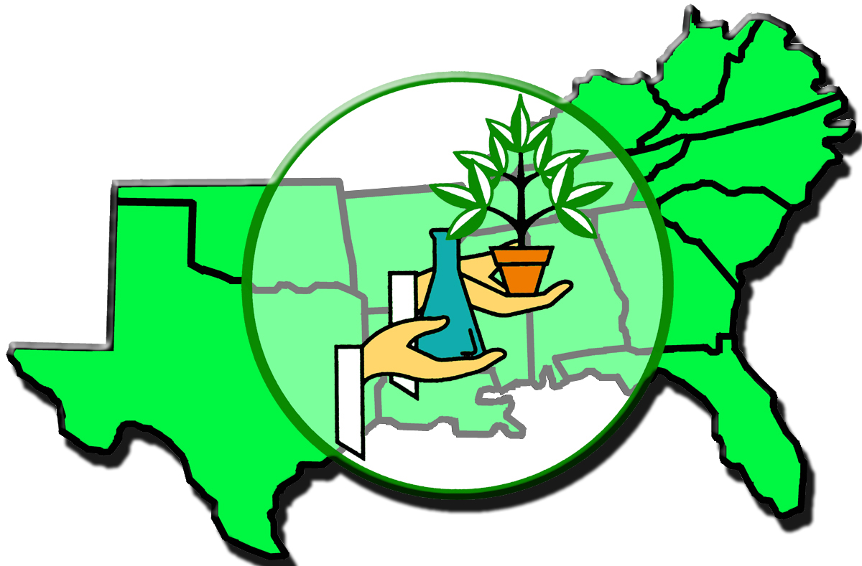
68th ANNUAL MEETING

Southern Region
of the
American Society for Horticultural Science

February 2-4, 2008
Dallas, Texas

Meeting Room Locations
Adam’s Mark Hotel & Conference Center
First Floor
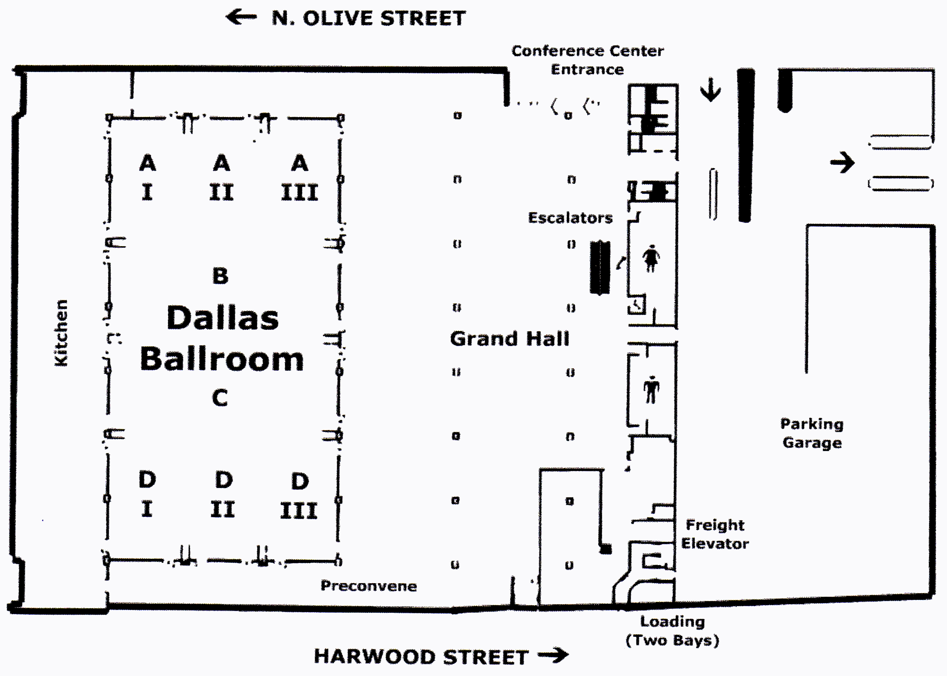
Second Floor
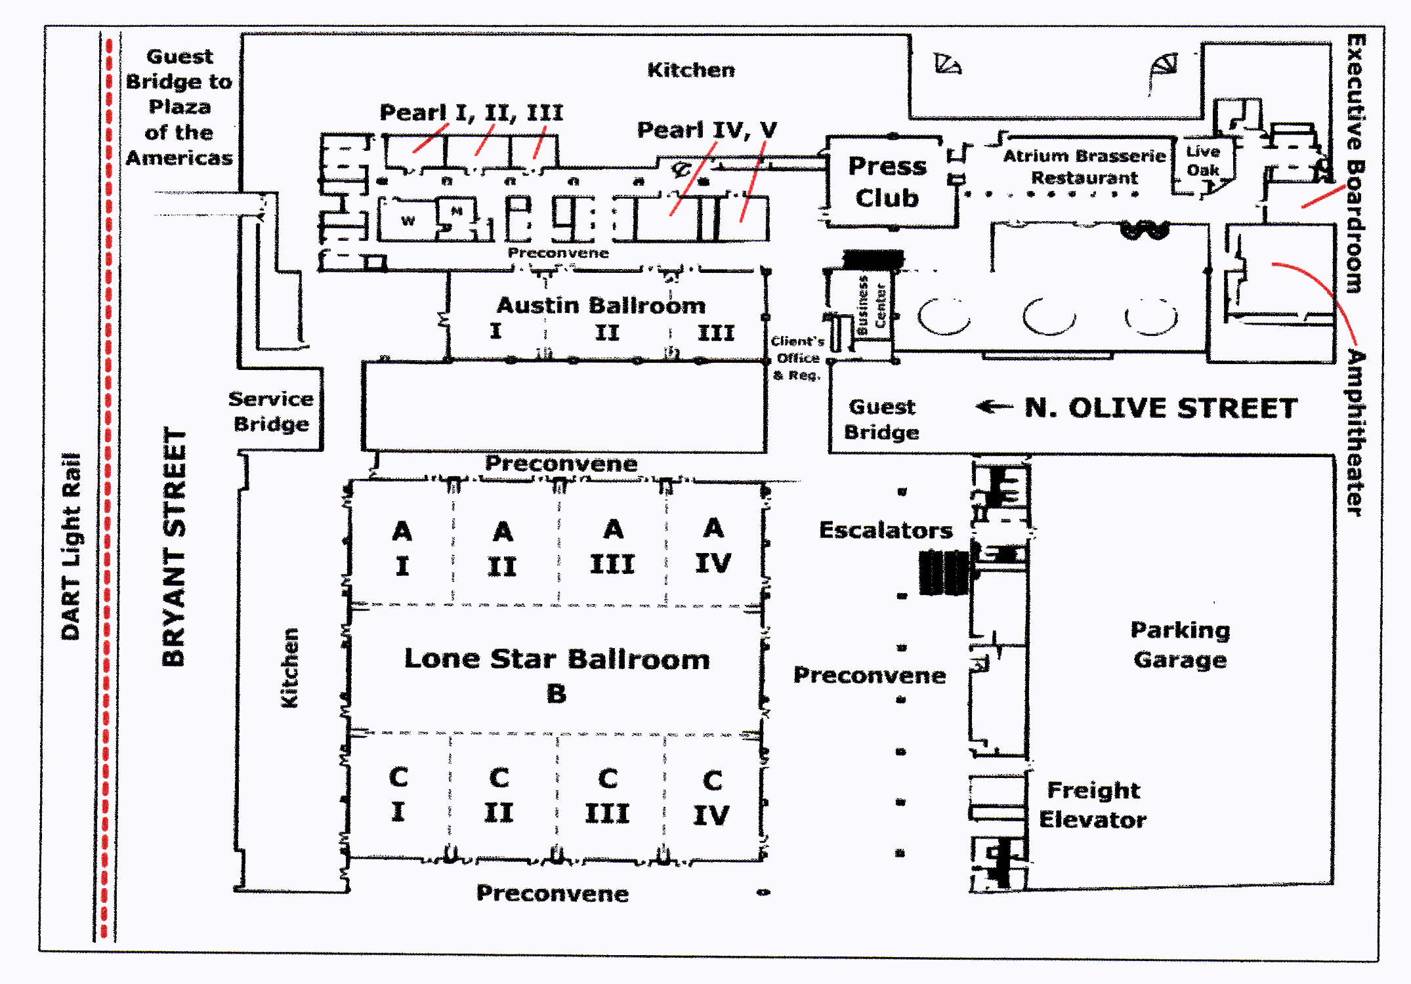
Forth Floor
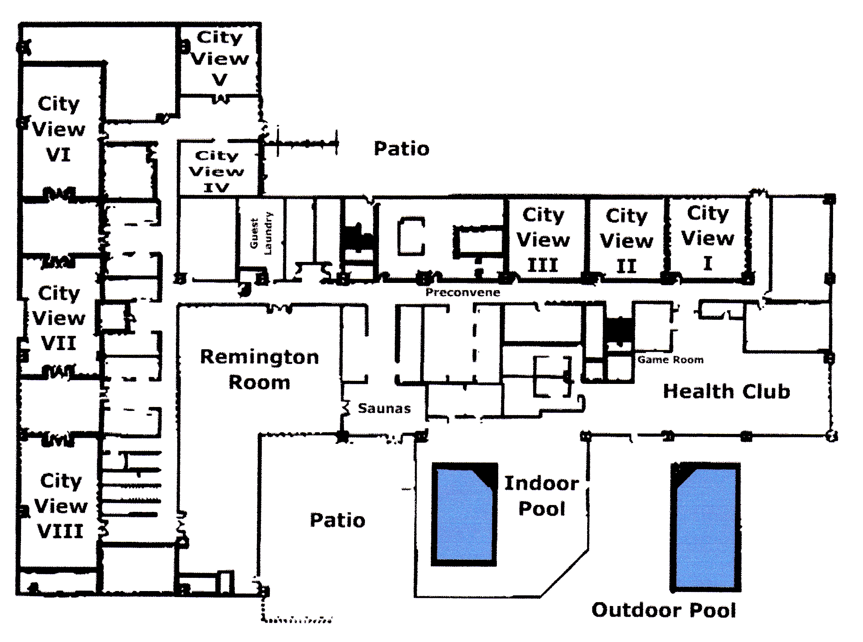
PROGRAM
68th ANNUAL MEETING
Southern Region
American Society for Horticultural Science

SPECIAL EVENTS AND SESSIONS

SATURDAY, FEBRUARY 2, 2008
7:00 am - 6:00 pm Registration
Presiding: Dave Reed
Room: Hotel, Lobby
8:00 am - 5:00 pm Pecan Research and Extension Forum
Presiding: Leo Lombardini
Room: Seminar/Amphitheater
8:00 am - 5:00 pm Southern Blueberry/Small Fruit Workers
Presiding: Joe Masabni
Room: Austin Ballroom 3
10:00 am - 11:30 pm ACB Program, Share Club Activities and Refreshments
Presiding: Susan Murphy, ACB President
Room: Austin Ballroom 2
12:00 noon 1:30 pm ACB Group Lunch on route to Dallas Arboretum tour
Presiding: Susan Murphy, ACB President
1:30 pm - 4:00 pm ACB Tour and Mixer: Dallas Arboretum
Presiding: Susan Murphy, ACB President
1:00 pm - 5:00 pm Horticulture Administrators
Presiding: David Williams
Room: Executive Boardroom
5:00 pm - until ACB Reception TBA
Presiding: Susan Murphy, ACB President
Room: Austin Ballroom 2 or TBA
5:00 pm - 6:00 pm Southern Region - ASHS Executive Committee Meeting
Presiding: Joe Kemble
Room: Executive Boardroom
SUNDAY, FEBRUARY 3, 2008
7:00 am - 6:00 pm Registration
Presiding: Dave Reed
Room: Grand Hall
8:00 am – 12:00 pm Set up Posters
Presiding: Bodie Pennisi
Room: Grand Hall
8:00 am – 12:00 pm J. Benton Storey Horticulture Judging Contest Setup
Presiding: Kim Pittcock, ACB Advisor
Room: Remington
8:00 am - 10:00 am Extension Section
Presiding: Kathryn Taylor
Room: City View Room 1
8:00 pm - 5:00 pm Watermelon Research Group
Presiding: Steve King
Room: Dallas Ballroom D1
8:00 am - 9:30 am J. B. Edmond Undergraduate Student Paper Competition
Presiding: Susan Murphy, ACB President
Penny Perkins-Veazie, SR-ASHS President
Pat Williams, Section Chair & Judging Coordinator
Room: Austin Ballroom 1
9:00 am – 12:00 pm Vigna Crops Germplasm Committee
Presiding: Richard Fery
Room: Austin Ballroom 2
10:00 am - 12:00 noon Norman F. Childers M.S. Student Paper Competition
Presiding: Doug Bailey, President Elect
TBA, Judging Coordinator
Room: Austin Ballroom 1
12:00 noon - 5:00 pm Poster Session Viewing
Room: Grand Hall
1:00 pm - 5:00 pm National Cowpea Improvement Association
Presiding: Bill Gebhardt
Room: Austin Ballroom 2
1:00 pm - 5:00 pm J. Benton Storey Horticulture Judging Contest
Presiding: Kim Pittcock, ACB Advisor
Room: Remington
3:00 pm - 5:00 am Education Section
Presiding: Amy Wright
Room: City View Room 5
1:00 pm - 3:00 pm Warren S. Barham Ph.D. Student Paper Competition
Presiding: Doug Bailey, President Elect
TBA, Judging Coordinator
Room: Austin Ballroom 1
3:00 pm - 5:00 pm Poster Session Viewing - Authors at Posters
Presiding: All Authors at all posters
All students in poster competition at posters
Bodie Pennisi, Judging Coordinator
Room: Grand Hall
3:30 pm - 5:00 pm SAAS General Session
Presiding: President, SAAS
Room: Dallas Ballroom A3
Title/Speaker: TBA
5:00 pm SAAS Reception and Super Bowl Party (big screen TV)
Room: Dallas Ballroom B/C

MONDAY, FEBRUARY 4, 2008
7:00 am - 10:00 am Registration
Presiding: Dave Reed
Room: Grand Hall
8:00 pm - 3:00 pm Poster Session Viewing
Room: Grand Hall
8:00 am - 10:30 pm Vegetable Crops Section
Presiding: Lynn Brandenberger
Room: City View Room 6
8:00 am - 10:30 pm Fruit Crops Section
Presiding: Steve Stringer
Room: City View Room 7
8:00 am - 10:30 am Floriculture, Ornamentals and Turf Section
Presiding: Wayne Mackay
Room: City View Room 4
8:00 am - 10:30 am Postharvest/Biotechnology/Plant Biology Section
Presiding: Niels Maness
Room: City View Room 5
9:00 am - 10:30 am ACB Business Meeting
Presiding: Susan Murphy, ACB President
Room: Dallas Ballroom A2
11:00 am - 12:30 pm Annual Business Meeting and Award Program
Presiding: Penny Perkins-Veazie, President
Room: Dallas Ballroom A2
1:00 pm - 2:00 pm Vegetable Crops Section
Presiding: Lynn Brandenberger
Room: City View Room 6
1:00 pm - 3:30 pm Fruit Crops Section
Presiding: Steve Stringer
Room: City View Room 7
1:00 pm - 3:30 pm Floriculture, Ornamentals and Turf Section
Presiding: Wayne Mackay
Room: City View Room 4
3:00 pm - 4:00 pm Poster Session Take Down
SECTION TITLES

SUNDAY, FEBRUARY 3, 2008

J. B. EDMOND UNDERGRADUATE STUDENT
PAPER COMPETITION
Room: Austin Ballroom I
Presiding: Susan Murphy, President, ACB
Penny Perkins-Veazie, President, Southern Region ASHS
Patrick Williams, Section Chair, Judging Coordinator
Abstracts: To publish your abstract in HortScience, see instructions at end of program.
Submit on disk at meeting or email to Chair (pat.williams@murraystate.edu)
8:00 am –9:30 am Order of presentations determined by drawing at beginning of contest.
Designing a Memorial Garden for the Riley Child Development Center Emphasizing Education. Susannah Horton* and Mary T. Haque, Dept. of Horticulture, Clemson Univ. Clemson, SC 29634-0375. (shorton@clemson.edu)
Evaluating Hard Pinch Timing of Dendranthemum x morifolium on Lateral Shoot Branching and Flowering Response. Stephen T. Blanchette*, Patrick N. Williams and Kris-Ann E. Kaiser, Murray State University, Murray, KY 42071-3345. (stephen.blanchette@murraystate.edu)
In vitro Shoot Proliferation of 'Dog Ridge' Grape. Kah-Yat Isaac Wong* and Daniel Lineberger, Department of Horticultural Sciences, Texas A&M University, College Station, TX 77843-2133. (kyiwong@tamu.edu)
Undergraduate International Opportunities: Two Approaches. Laureanne M. Bond*, Carolyn Robinson, Amy N. Wright, Jeff L. Sibley, and Donald J. Eakes, Department of Horticulture, Auburn University, AL 36849. (eakesdj@auburn.edu)

NORMAN F. CHILDERS M.S. GRADUATE STUDENT
PAPER COMPETITION
Room: Austin Ballroom I
Presiding: Doug Bailey, President-Elect, Southern Region ASHS
Abstracts: To publish your abstract in HortScience, see instructions at end of program.
Submit on disk at meeting or email to Chair (dabailey@uga.edu)
10:00 am – 12:00 noon Order of presentations determined by drawing at beginning of contest.
An Examination of National Plant Selection/Introduction Programs. Emily D. Harris*, Carolyn W. Robinson, Donald J. Eakes, and Jeff L. Sibley, Department of Horticulture, Auburn University, Auburn, Alabama 36849 (harried@auburn.edu)
Above-grade planting with organic matter improves post-transplant root growth and physiology of native shrubs. Julie L. Guckenberger* and Amy N. Wright, Department of Horticulture, Auburn University, Auburn, AL 36849 (guckejl@auburn.edu)
Consumer preference of hydroponic, greenhouse-grown fresh Cucumis sativus L. Leah Crosby¹*, Ana Luna², Ellen Peffley¹, and Leslie Thompson², Department of Plant and Soil Science, Texas Tech University, Lubbock, TX 79409-2122, ²Department of Animal and Food Science, Texas Tech University, Lubbock, TX 79409-2141 (leah.crosby@ttu.edu)
Determining optimum temperatures and seed enhancements for germinating Paspalum vaginatum seed. Dexter Fontenot*, Edward Bush, and Jeff Beasley, Louisiana State University, LSU AgCenter, 137 J.C. Miller Hall, Baton Rouge, LA 70803 (EBush@agcenter.lsu.edu)
Glyphosate drift toxicity on woody ornamental plants. Danille Mack*, Edward Bush and Jim Griffin, Louisiana State University, LSU AgCenter, 137 J.C. Miller Hall, Baton Rouge, LA 70803 (EBush@agcenter.lsu.edu)
Effects of Balanced Pruning and Cluster Thinning on Vigor, Yield, Fruit Composition and Wine Phenolics of Vidal blanc Grapevines. Patsy E. Wilson*, D. Archbold and S. K. Kurtural, Department of Horticulture, University of Kentucky Lexington, KY 40546-0091 (k.kurtural@uky.edu)

WARREN S. BARHAM Ph.D. GRADUATE STUDENT
PAPER COMPETITION
Room: Austin Ballroom I
Presiding: Doug Bailey, President-Elect, Southern Region ASHS
Abstracts: To publish your abstract in HortScience, see instructions at end of program.
Submit on disk at meeting or email to Chair (dabailey@uga.edu)

1:00 pm – 3:00 pm Order of presentations determined by drawing at beginning of contest.
Phytoremediation of contaminated aquifers using nursery crops. Kathryn Fontenot*, and Edward Bush. Louisiana State University, LSU AgCenter, 137 J.C. Miller Hall, Baton Rouge, LA 70803 (EBush@agcenter.lsu.edu)
Effect of elevated CO₂ and harvest schedule on photosynthetic efficiency and sensory quality of Allium fistulosum. Amanda Broome and Ellen Peffley, Department of Plant and Soil Science, Texas Tech University, Lubbock, TX 79409-2122 (amanda.broome@ttu.edu)
Glycoalkaloid levels in S. microdontum and S. jamesii accessions: A consideration in parental selection in breeding for high antioxidant activity in potato. M. Ndambe Nzaramba1*¹, John B. Bamberg², and J. Creighton Miller, Jr.¹, ¹Department of Horticultural Sciences, Texas A&M University, College Station, TX, 77843-2133, ²U.S. Potato Genebank, Sturgeon Bay, WI 54235-9620 (mnzaramba@tamu.edu)
Interference of Bacterial Cell-Cell Signaling by Citrus Flavonoids. Amit Vikram^{1*}, Palmy R. Jesudhasan², G. K. Jayaprakasha¹, Suresh D. Pillai², Bhimanagouda S. Patil¹ , ¹Vegetable and Fruit Improvement Center, Department of Horticultural Sciences, ²Department of Poultry Science, Texas A&M University, College Station, TX 77845. (avikram@ag.tamu.edu)
Lemon Seed Extracts: Antioxidant Capacity and Inhibition of Breast Cancer Cells. Jinhee Kim*, K. N. C Murthy, G. K. Jayaprakasha, Bhimanagouda S. Patil, Vegetable and Fruit Improvement Center, Department of Horticultural Sciences, Texas A&M University, College Station, TX 77845. (jinpi@neo.tamu.edu)

EXTENSION SECTION
Room: City View Room 1
Presiding: Kathryn Taylor
Abstracts: To publish your abstract in HortScience, see instructions at end of program.
Submit on disk at meeting or email to Chair (kctaylor@uga.edu)

8:00 am Design Your own Herbicide Equipment. Joseph Masabni*, Department of Horticulture, University of Kentucky, Princeton, KY 42445. (jmasabni@uky.edu)
8:15 am Private-Public Collaboration in Developing an Organic Vidalia Onion Industry. George Boyhan*, Ray Hicks, Reid Torrance, Mike,Dollar, David Spaid, Randy Hill, & Relinda Walker. Department of Horticulture, University of Georgia, Southeast Georgia Extension Center, P.O. Box 8112, GSU, Statesboro, GA 30460 (gboyhan@uga.edu)
8:30 am AgrAbility: Techniques for Making Gardening Accessible. *Richard G. Snyder¹ and Wayne Porter². Mississippi State University ¹Truck Crops Experiment Station, P.O. Box 231, Crystal Springs, MS 39059 (RickS@ra.msstate.edu) and ²Southeast Area Horticulture Agent, 410 Constitution Ave. 5th Floor, Meridian, MS 39301 (wporter@ext.msstate.edu)
8:45 am An Extension-based Viticulture Education Program for Oklahoma. Eric T. Stafne*, Brian Kahn, and Dale Maronek. 360 Ag Hall, Department of Horticulture and Landscape Architecture, Oklahoma State University, Stillwater, OK 74078 (eric.t.stafne@okstate.edu)
9:00 am Working with Local Industry to Develop a Value-Added Product. Kathryn C. Taylor, Dept. of Horticulture, University of Georgia, Byron, GA 31088 (kctaylor@uga.edu)
9:15 am Extension Section, Business Meeting: Discussion for improved planning for 2009 meeting. Kathryn C. Taylor, Dept. of Horticulture, University of Georgia, Byron, GA 31088 (kctaylor@uga.edu)

EDUCATION SECTION
Room: City View Room 5
Presiding: Amy Wright
Abstracts: To publish your abstract in HortScience, see instructions at end of program.
Submit on disk at meeting or email to Chair (awright@auburn.edu)
3:00 pm Contributions of Pre-collegiate and Collegiate Leadership Experiences to Leadership Development in Graduates. John C. Ricketts*. Agricultural Leadership, Education, and Communication, University of Georgia, 110 Four Towers, Athens, GA 30602 (jcr@uga.edu)
3:15 pm Crafting Pedagogies to Teach Adaptive Leadership and Learning. D.R. Mulvaney* and W.H. Shaw. College of Agriculture, Auburn University, Auburn, AL 36849 (mulvadr@auburn.edu)
3:30 pm Service Learning in Horticulture: What We've Learned. David Knauft¹*, David Berle¹, Anna Scott², and Steve Oliver². ¹Horticulture Department, ²Mathematics and Science Education Department, University of Georgia. Athens, GA 30602 (dknauft@uga.edu)
3:45 pm Pursing Victory with Honor: A Survey of Ethics and Sportsmanship in the Show Ring. Stanely E. Kelley and Marcy M. Beverly*. Agricultural and Industrial Sciences, Sam Houston State University, Huntsville, TX 77341 (agr_mmb@shsu.edu)
4:00 pm International Travel Preferences of Undergraduate and Graduate Horticulture Students. C.W. Robinson, L. Waters, Jr., A.N. Wright, and E. Harris*. Department of Horticulture, Auburn University, Auburn, AL 36849 (cwr0001@auburn.edu)
4:15 pm Incorporating Horticultural Training into an Undergraduate Sustainable Agriculture Curriculum. Tim Coolong*, Mark Williams, and Mark Keating. Department of Horticulture, University of Kentucky, Lexington, KY 40546-0091 (timcoolong@uky.edu)
4:30 pm Do Service Activities Really Attract Students? Dwayne Pavelock*, Doug Ullrich, and Doug Kingman. Department of Agricultural and Industrial Sciences, Sam Houston State University, Huntsville, Texas 77341 (agr_dxp@shsu.edu)

POSTERS
Room: Grand Hall
Presiding: Bodie Pennisi
Abstracts: To publish your abstract in HortScience, see instructions at end of program.
Submit on disk at meeting or email to Chair (bpennisi@uga.edu)

Set-Up: Sunday, 8:00 am – 12:00 pm
Poster Viewing Sunday, 12:00 pm – Monday, 5:00 pm
Authors at poster: Sunday, 3:00 pm - 5:00 pm
Student competition Sunday, 3:00 pm students at posters
Take-down: Monday, after Business Meeting and by 3:00-4:00 pm

“G” or “U” following the poster number indicates graduate and undergraduate poster, respectively, for the purpose of the National Cowpea Poster Competition. Undergraduate and Graduate students in the poster competition must be by their posters during the “Authors at Poster” time, Sunday at 3:00 pm.
Floriculture, Ornamentals and Turf
1G) Soil respiration and root growth of Sweetgum trees as affected by pavement type. Bhavana Viswanathan ¹*, Astrid Volder ¹, and Todd Watson ². ¹Department of Horticultural Sciences, Texas A&M University, College Station, TX 77843-2133, and ² Department of Ecosystem Science and Management, Texas A&M University, College Station, TX 77843-2138 (a-volder@tamu.edu)
2) Production of Ginkgo biloba Callus for the Growing area of Nutraceuticals. *Marihelen Glass and Monica Haddix. North Carolina A&T State University, Greensboro, NC 27411. (glassm@ncat.edu)
3) Variation in Organic Matter and Macronutrient Availability in Landscape Soils Under Landscape Fabric. Derald A. Harp, David Colbert, and Hanan Gopffarth*, Texas A&M University, 2600 S. Neal P.O. Box 3011, Commerce, TX 75429, (Derald_Harp@TAMU-Commerce.edu)
4) Effects of Varying Nitrogen Levels on Greenhouse Growth and Quality of Ornamental White Clover. Derald A. Harp and Steven Pulatie*, Texas A&M University, 2600 S. Neal P.O. Box 3011, Commerce, TX 75429, (Derald_Harp@TAMU-Commerce.edu)
5) In Vitro Factors Affecting Galax Seed Germination. Guochen Yang* and Zhongge (Cindy) Lu, Department of Natural Resources and Environmental Design, North Carolina A&T State University, Greensboro, NC 27411, (yangg@ncat.edu)
6) Can Salt Stress in Greenhouse Roses be Ameliorated by Supplemental Calcium Applications? Alma R. Solís-Pérez, A.R.* and Raul I. Cabrera. Dept. of Horticultural Sciences. Texas A&M University Research and Extension Center, 17360 Coit Rd., Dallas, TX 75252-6599. (r-cabrera@tamu.edu)
7) Evaluating the Landscape Performance of Miniature and Dwarf Crape Myrtle. (Lagerstroemia spp.) Cultivars for North Texas. Jennifer McCormick* and Raul I. Cabrera. Dept. of Horticultural Sciences. Texas A&M University Research and Extension Center, 17360 Coit Rd., Dallas, TX 75252-6599. (r-cabrera@tamu.edu)
8) Ornamental plant evaluation at the SFA Mast Arboretum -- two decades of trials and tribulations. Dawn Stover* and David Creech, SFA Mast Arboretum, PO Box 13000, Stephen F. Austin State University, Nacogdoches, TX 75962. (dparish@sfasu.edu)
9) Composted Cow Manure as a Substitute for Peat in Ornamental Plant Production. Gitta Shurberg, GCREC- Balm (UF-IFAS), 14625 CR 672, Wimauma, Fl 33598
10) Crape Myrtle Growth and Phenology in South Mississippi Christine Coker*, Patricia R. Knight, John M. Anderson, and Wayne McLaurin Mississippi State University, Coastal Research and Extension Center, 1815 Popps Ferry Road, Biloxi, MS 39532 (ccoker@ra.msstate.edu)
11) Evaluation of Natural Fertilizers for Greenhouse Crop Production. W.B. Evans* and G. Bi1. P.O. Box 231, MAFES Truck Crops Branch, Crystal Springs, MS 39059-0231. (wbe@ra.msstate.edu)
12) Effect of irrigation frequency on root growth, stem water potential, and net photosynthesis of Kalmia latifolia L. Matthew F. Wilkin and Amy N. Wright*. Department of Horticulture, Auburn University, Auburn, AL 36849 (awright@auburn.edu)
13) Effect of pavement type on water relations and gas exchange of mature Sweetgum trees. Astrid Volder¹* and Todd Watson ², ¹Department of Horticultural Sciences, Texas A&M University, College Station, TX 77843-2133, and ²Department of Ecosystem Science and Management, Texas A&M University, College Station, TX 77843-2138 (a-volder@tamu.edu)
14) Micropropagation and tissue culture of Hydrangea macrophylla for mutagenesis, ploidy manipulation, and possible transformation. Stephen P. Greer¹*, Sandra Reed², Jeff Adkins³, and Timothy Rinehart¹, ¹USDA-ARS, Southern Horticultural Laboratory, 810 Highway 26 West, Poplarville, MS 39470, ²USDA-ARS, National Arboretum, 472 Cadillac Lane, McMinnville, TN 37110, ³Department of Plant Sciences, Woodward Hall, Alumni Avenue, University of Rhode Island, Kingston RI 02881. (stephen.greer@ars.usda.gov).
Fruit Crops
15G) Aerial Root Development on Winegrape Cultivars Following a Spring Freeze. J. Andrew Puckette*, Eric T. Stafne, and Becky L. Carroll, 360, Agricultural Hall, Department of Horticulture and Landscape Architecture, Oklahoma State University, Stillwater, OK 74078 (eric.t.stafne@okstate.edu)
16) Digital Image Analysis of Pecans. Eric T. Stafne¹*, Douglas Karcher², Becky L. Carroll¹, and J. Andrew. Puckette1, ¹Agricultural Hall, Department of Horticulture and Landscape Architecture, Oklahoma State University, Stillwater, OK 74078, ²316 Plant Science, Department of Horticulture, University of Arkansas, Fayetteville, AR 72701 (eric.t.stafne@okstate.edu)
17) Response of three southern highbush blueberry cultivars to CPPU. D. Scott NeSmith, Dept. of Horticulture, Univ. of Georgia, Griffin Campus, 1109 Experiment Street, Griffin, GA 30223
18) Weed control in Blackberries using Ground Covers. D. J. Makus, USDA-ARS, Weslaco, TX 78596
19) Harpin Protein Use to Improve Early Season Fruit Size of ‘Queencrest’ Peach Robert T. Boozer* and James A. Pitts, 120 County Road 756, Auburn University Chilton Research and Extension Center, Clanton, AL 35045, (boozert@auburn.edu)
20) Effects of cultivar and location on muscadine antioxidant content and fruit quality. F.M. Woods¹*, E. Coneva¹, L. Howard², W.A. Dozier¹, Jr., J.E. Burkett³ and J. Pitts⁴. ¹101 Funchess Hall, Department of Horticulture, Auburn University, Auburn, AL 36849, ²2650 N. Young Ave Department of Food Science, University of Arkansas, Fayetteville, AR 72704, ³ Alabama Agriculture Experiment Station, 4725 County Rd. 40, Shorter, AL 36075, ⁴Alabama Agriculture Experiment Station, 120 County Rd. 756, Clanton, AL 35045. (woodsfm@acesag.auburn.edu)
21) Extending peak harvest of primocane-fruiting blackberries under hightunnel production. Christopher Vincent*, Heather Friedrich, M. Elena Garcia, Department of Horticulture, University of Arkansas, Fayetteville, AR 72701. (civince@uark.edu)
22) Viruses Affecting Blackberries in Alabama. Elina Coneva¹*, J. Murphy², B. Boozer³, G. Gray³, J. Miles³, W. East³, and L. Chapman³, ¹Department of Horticulture, Auburn University, Auburn, AL 36849-5408, ²Department of Entomology and Plant Pathology, Auburn University, Auburn, AL 36849-5413, ³ACES, Auburn University, 120 County Road 756, Clanton, AL 35045. (edc0001@auburn.edu)
Vegetable Crops
23G) Nutrient Uptake Efficiency in Grafted Tomato Production and Implications for Organic Production Systems. Suzanne O'Connell*, Mary M. Peet, Frank J. Louws, Cary L. Rivard, Chris D. Harlow, Department of Horticultural Science, North Carolina State University, Raleigh, NC 27695-7609 ( suzanne.oconnell@gmail.com)
24) Effects of Position in the Crop Canopy on Eggplant Fruit Quality. Brian A. Kahn*¹ and Mark E. Payton², Departments of ¹Horticulture and Landscape Architecture and ²Statistics, Oklahoma State University, Stillwater, OK 74078. (brian.kahn@okstate.edu)
25) Use of Paper Mulches for Weed Control In Summer Squash. Timothy Coolong. Department of Horticulture, University of Kentucky, Lexington, KY 40546-0091
26) Control of Mildew in Winter Squash . A.H. Beany¹, K. Pernezny2, P. J. Stoffella¹, N. Havranek², and J. Sanchez². ¹University of Florida, IFAS, Indian River Research and Education Center, 2199 South Rock Road, Fort Pierce, Florida 34945-3138, USA. ²University of Florida, IFAS, Everglades Research and Education Center, 3200 East Palm Beach Road, Belle Glade, Florida 33430-4702, USA.
27) Bite-Sized Tomatoes: Cultivars and Quality for a Farm-to-School Lunch Program. Warren Roberts*¹, Penny Perkins-Veazie², Jim Shrefler¹, and Merritt Taylor¹. ¹Oklahoma State University and ²USDA/ARS, 911 Highway 3, Lane, Oklahoma 74555 (wroberts@lane-ag.org)
28) Cantaloupe Types and Cultivars Grown with Organic and Synthetic Fertilizers. Warren Roberts*¹, Benny Bruton², Wayne Fish², and Merritt Taylor¹. ¹Oklahoma State University and ²USDA/ARS, 911 Highway 3, Lane, Oklahoma 74555 (wroberts@lane-ag.org)
29) Effect of elevated CO₂ and harvest schedule on biomass of three Allium species and sensory quality of A. fistulosum. Amanda Broome and Ellen Peffley, Department of Plant and Soil Science, Texas Tech University, Lubbock, TX 79409-2122. (amanda.broome@ttu.edu)
30) Sensory and Quality Assessment of Grazing Standing Corn versus Commercially Feed-lot Finished Beef. Husniye Imamoglu^{1*}, Patti. C. Coggins¹, James M. Martin², Glover B.Triplett³, Garrison Sensory Evaluation, Department of Food Science, Nutrition and Health Promotion, Mississippi State University, Starkville, MS 39762, ²Animal and Dairy Science Department, Mississippi State University, Starkville, MS 39762, ³Department of Plant and Soil Sciences, Mississippi State University, Starkville, MS 39762. (hi6@msstate.edu)
31) Nutrient Uptake Efficiency in Grafted Tomato Production and Implications for Organic Production Systems. Suzanne O'Connell*, Mary M. Peet, Frank J. Louws, Cary L. Rivard, Chris D. Harlow, Department of Horticultural Science, North Carolina State University, Raleigh, NC 27695-7609 ( suzanne.oconnell@gmail.com)
Post-Harvest and Biotechnology
32) Combined effects of Storage Time and Temperature on Sensory Characteristics of Plain Yogurt. Shweta Kumari^{1*}, Patti. C. Coggins¹, Julie C. Wilson¹, Dennis Rowe², Garrison Sensory Evaluation, Department of Food Science, Nutrition and Health Promotion, Mississippi State University, Starkville, MS 39762, ²Department of Plant and Soil Sciences, Mississippi State University, Starkville, MS 39762. (sk359@msstate.edu)
Monday, February 4, 2008

POSTERS
Room: Grand Hall
Presiding: Bodie Pennesi
Abstracts: To publish your abstract in HortScience, see instructions at end of program.
Submit on disk at meeting or email to Chair (bpennisi@uga.edu)

Poster Viewing Monday 8:00-11:00 am and 12:30-3:00 pm
Take-down: Monday, after Business Meeting and by 3:00-4:00 pm

VEGETABLE CROPS SECTION
Room: City View Room 6
Presiding: Lynn Brandenberger
Abstracts: To publish your abstract in HortScience, see instructions at end of program.
Submit on disk at meeting or email to Chair (lynn.brandenberger@okstate.edu)
Morning Session
8:00 am Weed control in Sweet Corn. Joseph Masabni*, Department of Horticulture, University of Kentucky, Princeton, KY 42445. (jmasabni@uky.edu)
8:15 am Evaluation of Cabbage, Broccoli, Cauliflower and Brussels Sprout Varieties in Georgia. W. Terry Kelley* and Denne Bertrand. Department of Horticulture, University of Georgia, Tifton, GA 31793 (wtkelley@uga.edu)
8:30 am Response of onion cultivars developed from greenhouse grown transplants to plant density and fertilizer rate. V. M. Russo, USDA, ARS, South Central Agricultural Research Laboratory, 911 Highway 3W, Lane, OK 74555. (vrusso-usda@lane-ag.org)
8:45 am Grafting methods for watermelon transplants. Richard L. Hassell. Clemson University CREC, 2700 Savannah Highway Charleston, SC 29414 (rhassel@clemson.edu)
9:00 am Sowing Date, Transplanting Date, Plant Population, and Variety Effect on Transplanted Short-Day Onion Production. George E. Boyhan*, Reid L. Torrance, Jeff Cook, Cliff Riner, and C. Randell Hill. Department of Horticulture, University of Georgia, East Georgia Extension Center, P.O. Box 8112, GSU, Statesboro, GA 30460 (gboyhan@uga.edu)
9:15 am Break
9:30 am Iris Yellow Spot Virus and the undiagnosed onion disease problem in Texas. Juan R. Anciso, Department of Horticulture, Texas Cooperative Extension, 2401 East Highway 83, Weslaco, Texas 78596. (j-anciso@tamu.edu).
9:45 am Pumpkin Quality and Yield in the Southeast. Annette L. Wszelaki¹*, Jonathan R. Schultheis² and W. Terry Kelley³, ¹Department of Plant Sciences, University of Tennessee, 252 Ellington Plant Sciences Bldg, 2431 Joe Johnson Dr., Knoxville, TN 37996, ²Department of Horticultural Science, 264 Kilgore Hall, Box 7609, North Carolina State University, Raleigh, NC 27695-7609, ³University of Georgia, Department of Horticulture, 4604 Research Way, P.O.Box 748, Tifton, GA 31793 (awszelak@utk.edu)
10:00 am Spinach Planting Density and Effects on Weed Control, Crop Injury and Yield. Russell W. Wallace*, Alisa K. Petty and Aaron L. Phillips. Texas A&M Research & Extension Center, 1102 East FM 1294, Lubbock, TX 79403. (rwwallace@ag.tamu.edu)
10:15 am Efficacy studies for Racer (ammonium nonanoate) a potential new postemergence herbicide for use in organic production. Lynn Brandenberger*¹, James Shrefler², and Charles Webber III³. ¹Department of Horticulture, Oklahoma State University, 360 Ag Hall, Stillwater, OK 74078, ²Oklahoma Cooperative Ext. Serv., Wes Watkins Research & Ext. Cntr. Box 128, Lane, OK 74555-0128, ³ARS Wes Watkins Research & Ext. Cntr. Box 128, Lane, OK 74555. (lynn.brandenberger@okstate.edu)
10:30 am Break to attend SR-ASHS Business Meeting at 11:00-12:30
Afternoon Session
1:00 pm Summer cover crop performance in the Gulf States. W.B. Evans¹* and C. Motsenbocker². ¹P.O. Box 231, MAFES Truck Crops Branch, Crystal Springs, MS 39059, and ²137 Julian Miller Hall, LSUAgCenter, Baton Rouge, LA USA 70803. (wbe@ra.msstate.edu)
1:15 pm Corn Starch as a Soil Amendment: Deal or no Deal? Eric Simonne*, Bob Hochmuth, and Aparna Gazula, Horticultural Sciences Department, University of Florida, Gainesville, FL 32611-0690. (esimonne@ufl.edu)
1:30 pm Application uniformity and shape of the wetted zone response to drip irrigation system operating pressure. Aparna Gazula*, Eric Simonne, and Bob Hochmuth, Horticultural Sciences Department, University of Florida, Gainesville, FL 32611-0690. (virgoinc@ufl.edu)
1:45 pm Greenhouse Production of Grafted Tomato Transplants. Xin Zhao¹*, Eric H. Simonne¹, Jeremy D. Edwards², and J. W. Scott², Department of Horticultural Sciences, P.O. Box 110690, University of Florida, Gainesville, FL 32611, ²Gulf Coast Research and Education Center, University of Florida, Wimauma, FL 33598. (zxin@ufl.edu)
2:00 pm Evaluation of the Growth and Production of Sorrel Germplasm on Calcareous Soils. Thomas W. Zimmerman*, Biotechnology & Agroforestry, University of the Virgin Islands, Agricultural Experiment Station, RR# 1, Box 10,000, Kingshill, St. Croix, VI, 00850

FRUIT CROPS SECTION
Room: City View Room 7
Presiding: Steve Stringer
Abstracts: To publish your abstract in HortScience, see instructions at end of program.
Submit on disk at meeting or email to Chair (sjstringer@ars.usda.gov)
Morning Session
8:00 am Fall Yield Characteristics of Primocane Fruiting Blackberries from the University of Arkansas Breeding Program Grown in Kentucky. Jeremiah D. Lowe^{1*}, Kirk W. Pomper¹, Sheri B. Crabtree¹, John R. Clark², and John G. Strang³. ¹Atwood Research Facility, Land Grant Program, Kentucky State University, Frankfort, KY 40601. ²Fruit Culture & Breeding, 316 Plant Science Bldg. University of Arkansas, Fayetteville, AR 72701. ³Department of Horticulture, N-318 Agricultural Sciences North, University of Kentucky, Lexington, KY 40546. (jeremy.lowe@kysu.edu)
8:15 am Nantahala’ red raspberry. Jim Ballington*, Gina Fernandez and Susan Bryson, North Carolina State University, Raleigh, NC (jim_ballington@ncsu.edu)
8:30 am The potential for extending the harvest season of organic brambles in the upper mid-south using high tunnels. Curt Rom*, , Heather Friedrich, Jason McAfee, Hyun-Sung Choi, M. Elena Garcia, Donn Johnson and Jennie Popp (crom@uark.edu)
8:45 am Establishment of an organic apple orchard in the upper mid-south. Curt Rom*, Jason, McAfee, H. Friedich, H. Choi, M. Elena Garcia, Donn Johnson, and Jennie Popp. (crom@uark.edu)
9:00 am Evaluation of Southern Highbush and Rabbiteye Blueberries in Kentucky. Joseph Masabni* and John Strang, Department of Horticulture, University of Kentucky, Princeton, KY 42445. (jmasabni@uky.edu)
9:15 am Break
9:30 am An analysis of two decades of production and climate data at Mill Creek Blueberry Farm, Nacogdoches, TX. David Creech¹*, and Henry Sunda², Department of Agriculture, P. O. Box 13000, Stephen F. Austin State University, Nacogdoches, TX 75962, ²Mill Creek Blueberry Farm, Rt. 1, Box 3170, Douglass, TX 75943 (dcreech@sfasu.edu).
9:45 am Images of and reflections on the developing blueberry industry in China. David Creech, Department of Agriculture, P.O. Box 13000, Stephen F. Austin State University, Nacogdoches, TX 75962. (dcreech@sfasu.edu)
10:00 am First year results with high tunnel strawberry production in the piedmont of North Carolina. Jim Ballington* and Kerry Olive, North Carolina State University, Raleigh, and Andy Myers and JoAnne Maury, Piedmont Research Station, Salsbury, N.C. (jim_ballington@ncsu.edu)
10:15 am ‘Galletta’ strawberry. Jim Ballington*, Kerry Olive and Susan Bryson, North Carolina State University, Raleigh)
10:30 am Break to attend SR-ASHS Business Meeting at 11:00-12:30
Afternoon Session
1:00 pm Performance of New Peach Rootstocks in South Carolina. Gregory L. Reighard*, David R. Ouellette, and Kathy H. Brock. Department of Horticulture, Clemson University, Clemson, SC 29634-0319. (grghrd@clemson.edu)
1:15 pm Influence of Rootstock and Fruit Thinning on Fruit Quality and Yield of ‘Jupiter’, ‘Mars’, ‘Marquis’, and ‘Neptune’ Grapes. Kenda R. Woodburn¹*, M. Elena Garcia¹, and R. K. Striegler ², ¹316 Plant Science, Department of Horticulture, University of Arkansas, Fayetteville, AR 72701, ²Institute for Continental Climate Viticulture and Enology, 108 Eckles Hall, 1406 East Rollins St., University of Missouri-Columbia, Columbia, MO 65211-5140. (woodburn@uark.edu)
1:30 pm Influence of rootstock on gas exchange of field grown merlot grapevines. Mike Krawitzky*, Thayne Montague, and Ed Hellman, Texas A&M University Experiment Station, Lubbock, TX 79403-6603 (thayne.montague@ttu.edu)
1:45 pm Performance of Muscadine Grape Cultivars in Alabama. Elina D. Coneva¹*, F. Woods¹, B. Wilkins¹, J. Sibley¹, W. A. Dozier¹ Jr., and J. Burkett². ¹Department of Horticulture, Auburn University, Auburn, AL 36849-5408, ²ACES, 4725 County Rd. 40, Shorter, AL 36075. (edc0001@auburn.edu)
2:00 pm Impact of Tree Girdling on Crop Load of ‘Sunprince’ Peach After Late Frost Event. Kathryn C. Taylor, Dept. of Horticulture, University of Georgia, Byron, GA 31088 (kctaylor@uga.edu)
2:15 pm Break
2:30 pm Weighted Linear Index Model for Vineyard Site Suitability Using Geographic Information Systems. S. Kaan Kurtural* and Imed E. Dami. University of Kentucky, Lexington, KY)
2:45 pm Daytime and nighttime temperature interactions on regulation of flowering in olives. Nasir, S.A. Malik, Jim Brockington, and Joe M. Bradford, USDA-ARS Weslaco, TX 78596. (Nasir.Malik@ARS.USDA.GOV)
3:00 pm Cultivar, Rootstock, and Training Method Influence flower Bud Production in PawPaw. Kirk W. Pomper¹*, Sheri B. Crabtree¹, Jeremiah D. Lowe¹, and Desmond R. Layne². ¹Land Grant Program, Atwood Research Facility, Kentucky State University, Frankfort, KY 40601. ²Dept. of Horticulture, Clemson Univ., Clemson, SC 29634 (kirk.pomper@kysu.edu)
3:15 pm Phenology and scab [Fusicladosporium effusum (G. Winter) Partridge & Morgan-Jones] disease expression vary by seed origin within a pecan [Carya illinoinensis (Wangenh.) K. Koch] seedling orchard. L. J. Grauke. USDA-ARS Pecan Breeding & Genetics, 10200 FM 50, Somerville, TX 77879. (ljg@tamu.edu)

FLORICULURE, ORNAMENALS AND TURF SECTION
Room: City View Room 4
Presiding: Wayne Mackay
Abstracts: To publish your abstract in HortScience, see instructions at end of program.
Submit on disk at meeting or email to Chair (wmackay@ufl.edu)
Morning Session
8:00 am Expression of Leaf Blight Symptoms Vary Among Provenances of Taxodium distichum (L.) L.C. Richard. G.V. McDonald*¹, G. Denny², A. King¹, D. Bryan¹, M.A. Arnold¹, and D.L. Creech³, Department of Horticultural Sciences, Texas A&M University, College Station, TX 77843-2133, ² Gulf Coast Research and Education Center, University of Florida IFAS, 14625 C.R. 672, Wimauma, FL. 33598, ³ Agriculture Department, Stephen F. Austin State University, SFA Station, P.O. 13000, Nacogdoches, TX 75962. (g-mcdonald@tamu.edu).
8:15 am Effect of Provenance on Salinity Tolerance of Taxodium. Geoffrey C. Denny¹* and Michael A. Arnold², IFAS Gulf Coast REC, Environmental Horticulture Department, University of Florida, Wimauma, FL 33598, ²Department of Horticultural Sciences, Texas A&M University, College Station, TX 77843-2133. (gcdenny@ufl.edu).
8:30 am Continuing Studies of Salinity Tolerance in Taxodium and Strategies for Asexual Propagation of Superior Clones. Lijing Zhou* and David Creech, SFA Mast Arboretum, PO Box 13000, Stephen F. Austin State University, Nacogodoches, TX 75962. (zhoul@titan.sfasu.edu).
8:45 am Salinity Tolerance of Three Rose Rootstocks. Genhua Niu* and Denise Rodriguez, Department of Horticultural Sciences, Texas A&M University, El Paso, TX 79927. (gniu@ag.tamu.edu).
9:00 am Integrated Crop Management in Woody Ornamentals. Javier Garces, Skinner Nurseries, 13000 SR 11,Bunnell, FL 32110. (jgarces@skinnernurseries.com).
9:15 am Break
9:30 am Screening Native and Ornamental Plants for Nutrient Abatement in Retention Ponds. Yan Chen* and Regina Bracy, Hammond Research Station, LSU AgCenter, 21549 Old Covington Highway, Hammond, LA 70403. (yachen@agcenter.lsu.edu).
9:45 am Long-term Benefits of Dairy Manure Compost to Urban Landscape Performance. Sloan, John¹*, Raul Cabrera¹, Cynthia McKenney², and Wayne Mackay³, Texas A&M University, TAES-Dallas, 17360 Coit Rd., Dallas, TX 75252, ² Department of Plant and Soil Science, Texas Tech University, Lubbock, TX 79409-2122, ³University of Florida, Mid-Florida Research and Education Center, 2725 S. Binion Rd., Apopka, FL 32703. (j-sloan@tamu.edu).
10:00 am Differences in Seasonal Landscape Performance of Liriope and Ophiopogons. Catherine Broussard, Edward Bush*, Allen Owings, and Marieanne Hollay, LSU AgCenter, School of Plant, Environmental and Soil Sciences, Baton Rouge, LA 70803. (EBush@agcenter.lsu.edu).
10:15 am Amending Recycled Hardwood Products for Acid Loving Plants. Edward Bush*, Allen Owings and Kiki Fontenot, LSU AgCenter, 137 J.C. Miller Hall, Baton Rouge, LA 70803. (EBush@agcenter.lsu.edu).
10:30 am Break to attend SR-ASHS Business Meeting at 11:00-12:30
Afternoon Session
1:00 pm Nutrient Applications to Reverse Whitening of Ivy Geraniums. Ritu Dhir* and Richard L. Harkess. Dept. Plant and Soil Sciences, Mississippi State University, Mississippi State, MS 39762. (rharkess@pss.msstate.edu)
1:15 pm Yield and Quality Effects of Colored Plastic Mulch on Four Field-Grown Cut Flowers. Kathryn Crowley and J. Raymond Kessler, Jr.*, Department of Horticulture, 101 Funchess Hall, Auburn University, AL 36849. (kessljr@auburn.edu)
1:30 pm Cajanus cajan as a Potential Ornamental for the Southern U.S. Cynthia McKenney¹*, Sue Metz², and Jennifer McCormick², Department of Plant and Soil Science, Texas Tech University, Lubbock, TX 79409-2122, ²Texas A&M University, TAES – Dallas, 17360 Coit Road, Dallas, TX 75252-6599. (cynthia.mckenney@ttu.edu)
1:45 pm Canna Cultivar Observations in 2007 Landscape Trials. Allen D. Owings* and Yan Chen, LSU AgCenter, Hammond Research Station, 21549 Old Covington Highway, Hammond, LA 70403. (aowings@agctr.lsu.edu)
2:00 pm 2:15 pm Break
2:15 pm Petunias - Summary of Recent Landscape Performance Observations. Allen D. Owings, LSU AgCenter, Hammond Research Station, 21549 Old Covington Highway, Hammond, LA 70403. (aowings@agctr.lsu.edu)
2:30 pm Caladium Height Control Using Plant Growth Regulators. Brian W. Trader* and Mengmeng Gu, Department of Plant and Soil Sciences, Mississippi State University, Mississippi State, MS 39762. (BTrader@pss.msstate.edu)
2:45 pm Increased Shoot Production in Caladium with Plant Growth Regulators. Brian W. Trader* and Mengmeng Gu, Department of Plant and Soil Sciences, Mississippi State University, Mississippi State, MS 39762. (BTrader@pss.msstate.edu)
3:00 pm Preliminary Evaluation of Open-Cell Foam for Extensive Green Roof Systems in Texas. Derald A. Harp^{1*}, Raul I. Cabrera², Wayne A. Mackay³, John J. Sloan², and Michael A. Arnold⁴, Texas A&M University – Commerce, 2600 S. Neal P.O. Box 3011, Commerce, TX 75429, ²Texas A&M University, TAES-Dallas, 17360 Coit Rd., Dallas, TX 75252, ³University of Florida, Mid-Florida Research and Education Center, 2725 S. Binion Rd., Apopka, FL 32703, ⁴Department of Horticultural Sciences, Texas A&M University, College Station, TX 77843-2133. (Derald_Harp@tamu-commerce.edu)

POST HARVEST/PLANT BIOTECHNOLOGY SECTION

Room: City View Room 5
Presiding: Niels Maness
Abstracts: To publish your abstract in HortScience, see instructions at end of program.
Submit on disk at meeting or email to Chair (niels.maness@okstate.edu)
8:00 am Antioxidant Properties of Oklahoma Grapes. Eric T. Stafne,¹* Sandra K. Peterson,² and Edralin A. Lucas², ¹360 Agricultural Hall, Department of Horticulture and Landscape Architecture, Oklahoma State University, Stillwater, OK 74078, ²422 HES, Department of Nutritional Sciences, Oklahoma State University, Stillwater, OK 74078. (eric.t.stafne@okstate.edu)
8:15 am Postharvest sterilization of feverfew (Tanacetum parthenium) leaves using heat, chlorine dioxide or ethylene gas. N.K. Damayanthi Ranwala* and J. W. Rushing, Clemson University Coastal Research and Education Center, 2700 Savannah Highway, Charleston, SC 29414. (nranwal@clemson.edu)
8:30 am Chemical profiling of basil varieties (Ocimum basilicum) grown in Oklahoma. Elif Kalkan*, Niels O. Maness and Donna Chrz, Department of Horticulture and Landscape Architecture, 360 Agricultural Hall, Oklahoma State University, Stillwater, OK 74078. (niels.maness@okstate.edu)
8:45 am Mother nature’s packaging and organization of carotenoids in watermelon and cantaloupe. Wayne W. Fish*, South Central Agricultural Research Laboratory, USDA-ARS, Lane, OK 74555. (wfish-usda@lane-ag.org)
9:00 am Lycopene accumulation in watermelon. Angela Davis¹*, Penelope Perkins-Veazie¹, Charles Webber III¹, and Stephen King², ¹USDA, ARS, Lane, OK 74555, ²Texas A&M University, College Station, TX, 77843. (adavis-usda@lane-ag.org)
9:15 am Break
9:30 am A correlation of internal and external ripening indicators in ‘Vanessa’ personal size watermelon. E.L. Vinson, III¹*, P. Perkins-Veazie², F.M. Woods¹, A. Davis², J.M. Kemble¹, W.G. Foshee¹ and J.E. Burkett³. ¹101 Funchess Hall, Department of Horticulture, Auburn University, AL 36849, ²USDA-ARS, SCARL 911 East Highway 3, Lane, OK 74555, ³Alabama Agriculture Experiment Station, 4725 County Rd. 40, Shorter, AL 36075. (vinsoed@auburn.edu)
9:45 am Effect of maturity at harvest on lycopene content and antioxidant activity in ‘Vanessa’ personal size watermelon. F.M. Woods¹*, E.L. Vinson, III¹, P. Perkins-Veazie², A. Davis², J.M. Kemble¹, W.G. Foshee¹ and J.E. Burkett³. ¹101 Funchess Hall, Department of Horticulture, Auburn University, AL 36849, ²USDA-ARS, SCARL 911 East Highway 3, Lane, OK 74555, ³Alabama Agriculture Experiment Station, 4725 County Rd. 40, Shorter, AL 36075. (woodsfm@auburn.edu)
10:00 am Effect of high tunnel and shade cloth on carotenoid content and antioxidant activity in selected bell pepper cultivars. F.M. Woods¹*, E.L. Vinson, III¹, W.G. Foshee, III¹, J.M. Kemble¹, W.G Sherrer¹, and J.E. Burkett², ¹101 Funchess Hall, Department of Horticulture, Auburn University, AL 36849, ²Alabama Agriculture Experiment Station, 4725 County Rd. 40, Shorter, AL 36075. (woodsfm@auburn.edu)
10:15 am Warm vs. cool production temperature affects on harvested orange-fleshed honey dew fruit antioxidants, minerals, sugars, and vitamin contents. G.E Lester¹* and D.M. Hodges², ¹Agricultural Research Service, USDA, Weslaco, TX, and Agriculture and ²Agri-Food Canada, Kentville, Nova Scotia (GeneLester@ARS.USDA.GOV)
Instructions for Submission of Abstracts
for Publication in HortScience

To Publish Your Abstract in HortScience:
- One of the authors must be an active member (dues paid) of the Southern Region ASHS
- The abstract must be submitted as a document file in the proper format.
- The abstract must be submitted to the Chair of the session by the deadline.

Submission of Abstract
File Format: Each abstracts must be submitted as a separate Word (.doc) file. If you use another word processing language, submit abstract in rich text format (.rtf).
Deadline: 1) At meeting: Give disk with file to the Chair of the session.
2) Email abstracts as an attached file to the Chair of the session within a few days after the meeting. See the Section Program for the Chair’s email address.

Abstract Format
Length: Limit the abstract body to about 2000 characters.
Font: 12 point, Times New Roman or similar
Format: Format abstract as below. Asterisk denotes presenting author.

Example Format
Molecular Marker-Derived Genetic Similarity Analysis of a Segregating Blackberry Population
Eric T. Stafne*¹, John R. Clark¹, and Kim S. Lewers²
¹316 Plant Sciences, Department of Horticulture, University of Arkansas, Fayetteville, AR 72701, ²USDA-ARS Fruit Lab, 10300 Baltimore Ave., BARC-West Bldg. 010A, Beltsville, MD 20705

A tetraploid blackberry population that segregates for two important morphological traits, thornlessness and primocane fruiting, was tested with molecular marker analysis. Both randomly amplified polymorphic DNA (RAPD) and simple sequence repeat (SSR) markers were used to screen a population of 98 genotypes within the population plus the two parents, ‘Arapaho’ and ‘Prime-Jim’® (APF-12). RAPD analysis averaged 3.4 markers per primer, whereas SSR analysis yielded 3.0 markers per primer pair. Similarity coefficient derived from the Dice index averaged over all individuals was 63% for RAPD markers, 73% for SSR markers, and 66% for RAPD and SSR markers together. The average similarity coefficients ranged from a high of 72% to a low of 38% for RAPD markers, 80% to 57% for SSR markers, and 73% to 55% for both. Comparison of the parents indicated a similarity of 67% for RAPD markers, 62% for SSR markers, and 67% for both. This is similar to a previous study that reported the similarity coefficient at 66%. Although inbreeding exists within the population, the level of heterozygosity is high. Also, evidence of tetrasomic inheritance was uncovered within the molecular marker analysis. This population will be used to identify potential markers linked to both morphological traits of interest. Further genetic linkage analysis and mapping is needed to identify any putative markers.

